IDEAL RELEASE VOLUME 1 © 2009

REVISION COMPUTER STUDIES PAPER 1
10 Sample Papers + Answers
By: Duncan Ouma Were

Produced and Marketed By;
Idealprice Consultants,
P.O. Box 15339-00100,
Nairobi.
Tel: 0716 41 39 41
Email: idealpricedirector@gmail.com
© 2009

SAMPLE PAPER 1
COMPUTER STUDIES PAPER 1
451/1
SECTION A (40 MARKS)
ANSWER ALL QUESTIONS IN THIS SECTION.
1. (a) Give a reason for each of the following disk management techniques. (1¹/₂ mks)
- Disk partitioning
- Disk compression
- Disk defragmenting
(b) Define the term internet. (1mk)
2. (a) Define utility software. (1mk)
(b) Describe the use of the following utilities. (3mks)
- Linkers
- Debuggers
- Loaders
3. (a) Explain the concept of distributed databases. (1mk)
(b) Give two advantages of distributed databases. (2mks)
4. (a) Write the acronym BIOS in full. (¹/₂mk)
(b) What is the use of BIOS in a computer system. (1mk)
5. (a) Briefly describe how the following data security measures function. (3mks)
(i)Audit trail
(ii) Log files
(iii) Firewalls
(b) Give any two reasons why passwords may not be reliable as security control measures. (2mks)
6. (a) Explain two uses of forms in database design. (2mks)
(b) i) Define the term control as used in report and form design. (1mk)
(ii) Explain briefly the difference between bound and unbound controls. (2mks)
7. (a) List any two components of a spreadsheet. (1mk)
(b) In a worksheet, the marks scored by ten students are stored in cell B3 to B12.
(i) In cell C3, show an expression you would use to obtain positions of the students using marks scored in descending order. (2mks)
(ii) In cell B13, write an expression you would use to extract the highest score from the marks.
(1mk)
8. Give the function of a surge suppressor. (1mk)
9. Explain the meaning of the term bolding. (1mk)
10. The table below shows the records of four students.
Admission number | Sex | Marks | class
026  118  150  152 | F  M  F  M | 70  40  50  30 | 4  3  3  4
Given the following logical expression.
IF NOT ( (SEX = ‘F’) AND (MARKS =>50) and (CLASS=3))
Indicate the result of the expression when applied on the record with admission 150. (2mks)
11. (a) List any two types of signals that can be used in data transmission. (1mk)

(b) Explain the concept of “Line of sight” in wireless communication. (2mks)
(c) Give a reason why a communication satellite has to rotate at the same rate as the earth.
(1mk)

12. What is a logical error in a program? (1mk)
13. List any two methods one can use to test a program. (1mk)
14. (a) Define the term e-mail. (1mk)
(b) Give two disadvantages of using e-commerce rather than the conventional method of carrying out business. 2mks)
15. (a) Give a reason of formatting a document. (1mk)
(b) Give any two word processor softwares. (1mk)

SECTION B (60 Marks)
Answer question 16 and any other THREE questions from this section.
16. (a) Explain the following characteristics of an object oriented programming language. (2mks)
(i) Properties
Methods
Events
Objects
- (i) Give two differences between interpreting and compiling a high level language.
(2mks)
(ii) Give an advantage of compiling over interpreting a program. (1mk)

- The formula of finding the roots of a quadratic expression is given here below
root = -b+ b² – 4ac
2a
In finding the roots, the values a, b, and c, are identified and then the discriminant i.e b² – 4ac is calculated.
If the discriminant is negative, then the roots are termed as “imaginary”, otherwise the two roots are calculated using the formula.
- Write a pseudo code that will solve the problem above. The values of a, b and c are entered from the keyboard. (5mks)
(ii) Write a program using either Pascal or c languages to find the two roots. (5mks)
17. (a) (i) Explain the meaning of the term file organization. (1mk)
………………………………………………………………………………………..
………………………………………………………………………………………..
- Indicate the method of file access for the following file organisation methods.
Indexed sequential
Sequential
Serial
Random
(b) The diagram below shows the data processing cycle.
Data collection
Data input

Information output
Data processing

(i) List the six stages of data collection in their correct order. (3mks)
(ii) List any four data collection media that can be used to collect data.(2mks)
(iii) List and explain the three methods that can be used to accomplish the task of
processing data. (3mks)
- Explain the difference between:-
(i) Logical and physical files. (2mks)
………………………………………………………………………………………..
(ii) Transcription and transposition errors. (2mks)
18. Organisations use massive resources to develop information systems.
(a) (i) Define the term information system. (1mk)
(ii) Describe any three elements of an information system. (3mks)
(iii) What is the main purpose of an information system. (¹/_{2 mk})

(b) During system analysis, information has to be gathered to enable the analyst understand the system under study.
- Explain two methods available to an analyst to enable him gather information. (2mks)
- Give two advantages and two disadvantages for each of the answers in b (i) above. (4mks)
(c) Documentation for any system developed is important.
(i) Explain the meaning of system documentation. (1mk)
(ii) Describe any two reasons why documenting a system is important(2mks)
(iii) What is system review? (1/2mk)
(iv) List two types of system maintenance. (1mk)
19. (a) Describe the use of the following buses. (3mks)
- Data bus
- Address bus
- Control bus
(b) In relation to the control unit of the CPU, explain the three stages of the fetch execute cycle. (3mks)

(c) A CPU has got registers for internal operations.
- Define the term register. (1mk)
(ii) Describe the functions of the following registers. (3mks)
Instruction register
Working register
Accumulator.
(d) Indicate an area of application for. (3mks)
- Joystick
- Touch screen
- Graphic tablet
(e) Explain the difference between softcopy output and hardcopy output.(2mks)
20. (a) (i) Define the term telecommuting. (1mk)
(ii) Give two advantages of telecommuting
(b) (i) What is the difference between a teletext and a videotext for communication.
(¹/₂mks)
(ii) Give two advantages of using teletext / videotext for communication. (2mks)

(c) Describe THREE ways in which computers are used as industrial systems. (4¹/₂mks)
In relation to weather forecasting
(i) Write GIS in full. (1/2mk)
(ii) What is the use of GIS. (1mk)
(e) Use one’s complement to calculate. (3¹/₂mks) 1101 – 11

MARKING SCHEME
SAMPLE PAPER 1
451/1

- a) Give a reason of the following disk management techniques
i) Disk partitioning
To enable two or more operating systems to be used
To enable back – ups to be created
- Disk compression
To create enough storage space
- Disk defragmenting
To enable the system search for files faster
- Define the term internet
A connection of computer networks
- a) Define utility software
A software to accomplish common tasks
b) Describe the use of the following utilities
i) Linkers Enables several sub programs to be connected when running
ii) Debuggers To assist in tracing and removing errors from a program
iii) Loaders : Assists in transferring an application from a secondary storage to a primary storage when running the application
- a)Explain the concept of distributed databases
This is where databases are created for different departments in an organizations in different computers that are networked.
  - Give two advantages of distributed databases
    - Searching of items is fast
    - No interference of other department’s data
- a) Write the acronym BIOS in full
Basic Input output system
  - What is the use of BIOS in a computer system
A software used to guide the computer during the process of booting
- a) Briefly describe how the following data security measures function
  - Audit trail : A study to evaluate if a system is secure. Acts as a measure of preventing crimes from occurring
  - Log files: Records the activities taking place in a computerized system
  - Fire walls : Acts as a vetting system for remote request of information from a system.
  - Give any two reasons why passwords may not be reliable as security control measures
    - Can be easily revealed by ignorant users
    - Can be broken into by determined crackers through trial and errors
- a) Explain two uses of forms in database design
    - Enter data into tables
    - Display data from tables & queries
b) i) Define the term control as used in report and form design
- Is anything that is created or added to a form / report during design
ii) Explain briefly the difference between bound and unbound controls
Bound controls have fields as the source of data while unbound have got no fields as data sources.
- a) List any two components of a spreadsheets
    - Graphs and charts
    - Databases
    - Worksheets
  - In a worksheet, the marks scored by ten students are stored in cell B3 to B12.
- In cell C3, show an expression you would use to obtain positions of the students using marks scored in descending order
= RANK ( & B & 3 : & B & 12,O)

- In cell B13, write an expression you would use to extract the highest score from the marks (1mk)
= Max ( B3 : B12)
- Give the function of a surge suppressor
To protect computers & other devices from the effects of extra power.
- Explain the meaning of the term bolding
Increasing the intensity of text

- The table below shows the records of four students

ADMISSION NUMBER | SEX | MARKS | CLASS
026 | F | 70 | 4
118 | M | 40 | 3
150 | F | 50 | 3
152 | M | 30 | 4

Given the following logical expressions.
If NOT (SEX = ‘F’ ) AND ( MARKS = > 50 ) AND (CLASS = 3)
Indicate the result of the expression when applied on the record with admission 150
- FALSE
- a) List any two types of signals that can be used in data transmission
    - Digital signals
    - Analog signals
b) Explain the concept of ‘ Line of sight’ in wireless communication
This is where a receiver and a transmitter must “see” each other for them to communicate . This is why they are usually put on high grounds.
  - Give a reasons why a communication satellite has to rotate at the same rate as the earth
It has to remain is sight with the earth stations i.e it has to be geostationery.
- What is a logical error in a program ?
An error that results into wrong result of processing i.e the logic of processing is wrong
- List any two methods one can use to test a program
    - Dry running
    - Using test data
    - Using a translator or
    - Using a debugger – special program to trace errors

- a) Define the term e-mail
Sending and receiving electronic letters through the internet.
  - Give two disadvantages of using e- commerce rather than the conventional method of carrying out business
    - One can be conned easily
    - No proper laws governing the business
    - You deal with people without meeting them.
- a) Give a reason or formatting a document
    - Make it attractive
    - Draw attention to important
- Give any two word processor softwares
    - Ms word
    - Word perfect
    - Wordstar
    - Word pro

SECTION B (60 MARKS)
Answer question 16 and other 3 question from this section
- a) Explain the following characteristics of an object oriented programming language.
  - Properties: Data or characteristics found in an object e.g. size, colour e.t.c
  - Methods. Methods are actions to be performed by an object e.g. instructions
  - Events Actions / things that happen e.g. clicking, pressing a keyboard button e.t.c
  - Objects Is a collection of information and actions
b) i) Give two differences between interpreting and compiling a high level language.
- Interpreting converts an instruction, runs it before proceeding to the next while compiling converts all instructions before running them
- Interpreting does not store object program while compiling stores an object code.
ii) Give an advantage of compiling over interpreting a program
Compiling is faster than interpreting.

c) The formula of finding the roots of a quadratic expression is given here below
root = -b― √ b² – 4ac
2a

In finding the roots, the values a,b, and c are identified and then the discriminant i.e.
b² – 4ac is calculated
If the discriminant is negative , then the roots are termed as “ imaginary” otherwise the two roots are calculated using the formula.

- Write a pseudo code that will solve the problem above. The values of a, b and c are entered from the keyboard .

START
Enter values a,b& c
Read a,b & c
Calculate discriminant using b² - 4 x a x c
If discriminant < o then
Display ‘ roots imaginary
Else
Calculate root 1 = -b + sqrt ( discriminant / 2 x a)
Calculate root 2 = - b – sqrt ( discriminant / 2 x a)
Display root 1 , root 2
END
( Award 1 mk for start & end)
( Award 1 mk for reading a,b & c)
( Award 1 mk for testing discriminant)
( Award 1 mk for proper calculation of roots)
( Award 1 mk for output of roots & imaginary

- Write a program using either Pascal or c languages to find the two roots (5mrk)
    - In Pascal;
Program quad ( input, output);
Var
Root1, Root2: real;
A,b,c : integer;
Begin
Writeln (‘ enter the value of a,,b and c’) ;
Readln (a,b,c);
If (sqr (b)  4 * a * c) then
Writeln (‘ Roots are imaginary’ );
else
Begin
Root 1: = -b+ sqrt (sqr(b) -4 *a*c/ ∕2 *a);
Root 2 : = -b-sqrt (sqr(b) -4 *a*c //2 *a);
writeln (‘Root1 = , Root1);
writeln (‘Root 2 = ‘, Root 2);
end;
end

Award 1 mk for declaration of variables
    - Should be enough
    - Should be correct data type
    - Should be syntactically correct
Award 1 mk for input & output
    - Check proper reading of values a,b & c
    - Check output of two roots and imaginary
Award 1 mk for proper use of a selection statement
    - Check syntax
    - Check alternative e.g. else
Award 1 mk for use of proper calculations in roots.
    - Check breakdown of the equation into a simpler format-
    - Check syntax of any function used e.g sqr, sqrt, brackets e.t.c
Award 1 for neatness
    - Check cancellations
17. a) i) Explain the meaning of the term file organization ( 1mk)
Is the way data is stored in a file
ii) Indicate the method of file access for the following file organization methods
Indexed sequential- Direct
Sequential -serial or binary search
Serial- serial
Random - Direct
- The diagram below shows the data processing cycle ( award ½ each)
Data collection
Data input

Information output
Data processing

- List the six stages of data collection in their correct order (3 marks)
    - Data creation
    - Data transmission
    - Data preparation ( Award ½ for each listed)
    - Media conversion ( Deduct 1 mk if not in correct order)
    - Data validation
    - Sorting
ii) List any four data collection media that can be used to collect data(2mrks)
MICR
OCR – portable Encoding devices e.g tape recorders
Portable encoding devices e.g tape recorders.
Barcode readers ( wand scanner)
Key – to - diskette (Award ½ each)
iii) List and explain the three methods that can be used to accomplish the task of processing data ( 3mks)
    - Manual – No machine used – may be pen and paper
    - Mechanical – simple machines are used to process data
    - Electronic – Automatic devices that work under the guidance of programs are used to process data e.g. computer.
( Award ½ for each listed method)
(Award ½ for each correct description)
c) Explain the difference between
i) Logical and physical files ( 2mks)

A logical file is a user view on the arrangement structure and processing of a file while a physical file is the actual arrangement of a file on a storage device
( Award 1 for each part)

ii) Transcription and transposition errors ( 2mks)

    - Transcription errors occurs during the process of changing data to a form a computer understands.
    - Transposition errors occurs as a result of interchanging position of characters e.g. typing 163 instead of 136
(Award 1 for each part)
18. Organisations use massive resources to develop information systems
a) i) Define the term information system (1mk)
This is a person machine system that is highly integrated designed to provide managerial with information.
ii) Describe any three elements of an information system (3mks)
- Input - Controls - boundaries
- Process - Environment - Interface
- Output - Feedback
iii) What is the main purpose of information system ( ½ mk) To provide information that will assist in making decisions.

b) During system analysis, information has to be gathered to enable the analyst understand the system under study
i) Explain two methods available to an analyst to enable him gather information (2mks)
i) - Use of interview face to face interpersonal role – to get information
ii) - Document review – taking document to get information (Award ½ for proper description).
iii) - Questionaires – writing questions down to be answered
iv) Observation – Going to the place of work and seeing what is happening.

ii) Give two advantages and two disadvantages for each of the answers in
bi) above (4mks)
I : Interview
Advantages
- Flexible – one can change according to circumstances
- Can get information on complex subjects
- People enjoy being interviewed
- Can be used to evaluate validity of information gathered.
Award ½ for each adv.
Disadvantages
    - Requires more skills – communication
    - Time consuming – one person at a time
    - Puts more pressure on respondents to provide immediate feedback
    - Questions are less standard
Award ½ for each disadv.
2. Questionnaires
Advantages.
    - Less skills required
    - Questions are standard
    - Can be administered to a large number simultaneously
    - No pressure on the respondent to give immediate feedback
    - Respondents feel secure because of anonymity
Award ½ for each adv.
Disadvantages
- Postal questionnaires may get lost
3. Observation
Advantages
– Enables one to get as close as possible to the system
    - One gets first hand information
Disadvantages
    - You intrude into one’s working place
    - Attitudes and motivation can not be observed
    - Takes a lot of time since you observe one event at a time
    - Respondents can change the pattern of working due to your presence leading to misinterpretation
4. Document review / Reading around the system
Advantages
    - Enables one gain background knowledge of systems
    - Enables an analyst to take time to study the document
    - The documents are useful in documentation of the system
Disadvantages
    - Time consuming & expensive
    - Written documents become outdated faster
    - Documents show only official state of affairs.
ci) Documents for any system developed is important
- Explain the meaning of system documentation ( 1mk)
Act of providing information on the system
- Describe any two reasons why documenting a system is important (2mks)
    - Enable maintenance to take place
    - Allow one to understand a system
    - Enables users to ensure that the system meets their requirements
    - Supports entire life cycle of system development (Award 1 for each)
- What is system review ( ½ mk)
A study after the system has been implemented to assess how it is working compared to what was planned / intended
- List two types of system maintenance ( 1mk)
    - Emergency maintenance – For correcting errors
    - Development maintenance – For improving the system. Also called modification maintenance (Award ½ for each listed type)
19. a) Describe the use of the following buses ( 3mks)
i) Data bus
A channel that transmits data from one element to another (Award 1)
ii) Address bus
A channel that transmits addresses to be used in identifying location of an instruction or devices (Award 1)
iii) Control bus
A channel to transmit control signals from the control unit to other parts of a computer. (Award 1 )
b) In relation to the control unit of the CPU, explain the three stages of the fetch execute cycle ( 3mks)
- An instruction is fetched from the memory
- An instruction is interpreted (decoded)
- An instruction is implemented
(Award 1 mk for each stage correctly described)
c) A CPU has got registers for internal operations
i) Define the term register (1mk)
A one cell storage unit in the CPU
ii) Describe the functions of the following registers ( 3mks)
Instruction register
To store an instruction part of an expression / code(Award 1)
Working register
Stores a data part of an expression / code(Award 1)
Accumulator
Stores intermediate results or results from immediate processing (Award 1)
d) Indicate an area of application for ( 3mks)
i) Joystickplaying games
ii) Touch screenin areas where people are standing or wet areas –e.g hotels
iii) Graphic tablet for designing e.g. CAD
e) Explain the difference between softcopy output and hardcopy output(2mks)
Softcopy is information on intangible output devices e.g. on monitors, sound light emitting diodes while hardcopy output is information on physical media e.g. on printed papers(Award 1 for each part)
20. a) i) Define the term telecommuting ( 1mk)
A situation where a worker sits at home and works there using a computer connected to place of work. The work is sent to the place of work using the network
ii) Give two advantages of telecommuting ( 2mks)
    - Reduces travel expenses
    - Reduces traveling stress
    - Reduces interruptions at places of work
    - Reduces need for offices (award 1 mk for any two)
b) i) What is the difference between a teletext and videotext communication ( ½ mks)
- A teletext is one way communication whereas a videotext is two way communication.
ii) Give two advantages of using teletext/ videotext for communication ( 2mks)
    - Tvs are readily available hence can reach many people
    - Easier to use ( Award 1 for each)
c) Describe THREE ways in which computers are used as industrial systems. ( 4 ½ mks)
- CAD / CAM – For designing & manufacturing products
- Process control – To monitor and control working of processes in manufacturing plants.
- Simulation – To enable experimentation to take place with the use models
(Award ½ for each listed)(Award 1 for each correct explanation)
d) In relation to weather forecasting
i) Write GIS in full ( ½ mk)
Geographical information system
ii) What is the use of GIS ( 1mk)
Enables weather patterns to be displayed on the world map.
e) Use one’s complement to calculate ( 3 ½ mks)
1101 – 11
- Change nuend to 4 digits
i.e 11 0011 (Award 1 mk for place values)

Find the complement of nuend
-
i.e 1100 (Award 1 mk for complement)

- Add
1101
1100 +
11001 (Award 1 mk for correct addition)

- Carry end – round carry
1001
+ 1 (Award ½ for correct end- round carry
1010

Ans = 1010₂

SAMPLE PAPER 2
451/1
BUSINESS STUDIES PAPER 1
SECTION A (40 Marks)
Answer All questions in this section.
- Define the term downloading in relation to the internet (2 Mks)
- State two reasons why personal computers are so important to (and common with) small businesses and entrepreneurs (2 Mks)
- (a) Write down an algorithm for Memorizing a short play (2 Mk)
(b) Draw a flowchart for the algorithm above (3 Mk)
- What’s the difference between a trackball and a mouse (1 Mks
- What is the: (3Mks)
- Binary value of the decimal number 7 …………………………………………………………
- Decimal value of hex A …………………………………………………………
- Hex value of binary number 11 …………………………………………………………
- Use the terms scan code and interrupt to describe how the keyboard works (2Mks)
- Assuming you want to buy a black-and-white printer. State briefly, four important factors/criteria you’d use to evaluate the different types of printers (4Mk)
- Mention three iteration statements (loop types) commonly used in programming
(3Mks)
- Describe the other program control structures besides iteration (3Mks)
- Distinguish between filtering and sorting data as used in Spreadsheets? Use examples to explain your answer (2 Mks)
- Write down the full meanings of the following computing Acronyms: (4 Mks)
    - RISC…………………………………………………………………………………………………
    - POST ……………………………………………………………………………………………
- Briefly outline six roles of a Network administrator (3 Mks)
- What do you understand by the term device driver? (2 Mks)
- Distinguish between baud rate and bit rate (2Mks)
- State two advantages of: (2 Mks)
- CRT monitor
- Flat panel displays
SECTION B (60 Marks)
Answer question 16 and any other TWO Questions.
- (a) List four components of an information system (4 Mks)
        - Define the following systems related terms: (6 Mks)
- Data dictionary
- Feasibility
- Walkthrough
        - Briefly describe the five main stages of system development (5 Mks)
        - What is system documentation (2 Mks)
        - Why is Documentation important? (1 Mks)
        - At what stage of the system development cycle should documentation take place?
(1 Mks)

- Use the following Ms Dos Screen to Answer the questions that follow:

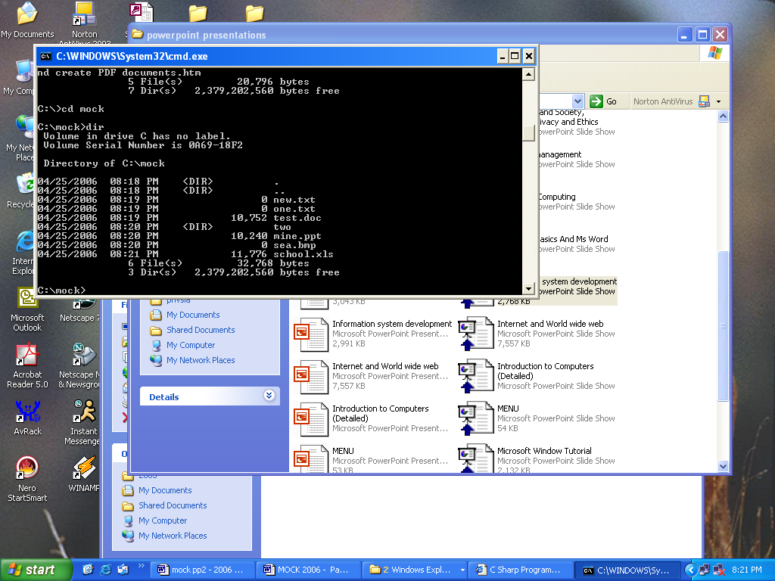
    - What’s the name of the current directory? ………………………………(1 Mks
    - List the folders in this directory (2 Mks)
    - List the files that exist in the current directory by filling in the table below (9 Mks)
File name | Type of file | Approximate size (Rounded off to the nearest kilobyte)
    - What command would make your prompt change to C:\>_ …………… (2 Mks)
    - Write down the statement that would: (6 Mks)
- Display only the files/directories whose names start with “s”
- Change the name of “sea.bmp” to “mombasa.jpg”
- (a) Describe any three physical LAN topologies (3 Mks)
(b) Define the following terms: (5 Mks)
- Protocol
- Server
- Gateway
- Repeater
- Bandwidth
(c ) Give two disadvantages of networking (3 Mks)
(d) Explain the line of sight principle in wireless communication (3 Mks)
(e) What’s the work of the following in networking? (6 Mks)
- Crimping tool
- Network interface card
- Network neighbourhood icon
- (a) Explain how computers are used in the following areas: (6 Mks)
- Law enforcement
- Banking
- A library
(b) List and describe the two types of DTP software (3 Mks)
(c ) Define: (6 Mks)
- Pseudocode
- Assembler
- Object code
(d) Your principal is intending to install a simple Internet connection in the school. List down the equipment/ services that she’ll require to achieve this (5 Mks)

MARKING SCHEME
SAMPLE PAPER 2
451/1

1. a) Data can be read (retrieved) and written (stored) in it  1
- RAM is temporary (volatile) storage because its contents disappear when the computer is switched
off  1
- Its content is user defined i.e. the user dictates what is to be contained in the RAM 1
- Static RAM is very fast, holds its contents as long as there is power whereas dynamic RAM is slower and holds its content for a short while even when power is on hence it requires refreshing (automatic rewriting) severally per second  1
2. A plotter 1
Because plotters specializes in producing big charts such as maps, pictures and drawings and mostly for printing geographical, architectural and engineering drawings such as maps which the company needs to produce
3. Multi User
UNIX, LINUX, NOVEL, WINDOWS 9X/NT/2000/XP, MAC OS, OS/2 (any 2)  2
Single user MS DOS  1
4. a) Because they allow the user to record data on them once but read the data as often as necessary 1
b) Back space - Used to erase character from right to left or use to erase a character that has just been typed 1
c) Delete:-Used to erase character from left to right OR used to delete the text or any part thereof 1
d) Space bar:- used to create space between words or character 1

5 (a) A Spreadsheet is essentially ledger sheet that lets one enter, edit and manipulate numeric data 1
- Uses of spread sheets
- Statistical analysis e.g average, mean, median e.t.c
- Accounting – calculate profits, prepare budgets calculate depreciation and appreciation e.t.c
- Data management e.g. sorting, filtering, print e.t.c
- Forecasting (“what if” analysis) (any 3 logical answer)

6 a) Hardware
- Processor type and speed
- Memory capacity
- Secondary storage any two
- Warranty stated, ½
- Expansion and upgrades mark each
- User needs good explanation ½
- Cost mark each
- Compatibility
- Service and support
- Clones

b) Software
- Authenticity
- Rehability
- User needs Any two stated
- User friendliness  ½ mark each
- System requirements
- Cost Good explanation
- Compatibility  ½ mark each
- Portability
- Documentation
- Training
- upgrades

7. a) Used in data representation especially  1 in ASCII code representation of data
b) 94 B₁₆ = 2379₁₀  1 must show the base if not – ½
8. Eaves dropping is intercepting of conversation by unauthorized recipient, deletion or insertion OR
integrity violation through wire tapping  any 1mk

Fire walls are computer hardware and /or software that help to filter the information that is being communicated 1
9. An information systems is a set of people,
a) procedures and resources that collect transforms and disseminates information in an organization 1

- - When and organization has  1 several branches
- When an organization has many employees
- When the system analyst/system development committee is too busy to carry out interviews

10. (i) when the person inputting the data is 1 handicapped e.g. has impaired hands
(ii) When the person inputting the data has no data input skills using other devices such as keyboard and mouse
11. Administrative
- Job rotation
- Forced vacation
- Accessed information should be granted on need to know basis and not on rank basis
- Enhance accountability within the organization
- Have division of labour and segregation of duties
- Select your personnel competitively i.e. know your employees (any two 2)

Logical Access Control
- Use of password  2
- Use of user name 

12. - Consuit with managerial, Administrative and technical staff to determine information needs data flows and system definitions
- Monitor systems to optimize performance perform back up and initiate recovery action in the case of system failure
- Co-ordinate system updates
- Provide assistance in testing new equipment and systems
- Co-ordinates support work and training in system use and access (any two 2)

13. These are moral principles and values that govern the action and decisions of an individual or group 1

14. Base band signal
Is a digital signal that is generated and applied to the transmission medium directly without modulation  1

Broad band transmission
Is transmission where an analogue signal is sent over the transmission medium using a particular frequency 1

15. a) Is the process of generating personalised letters or documents by combining a main document
with existing data source 1

b) This is the feature that automatically moves a word or cursor to the beginning of the next line if
it does not fit at the end of the current line

16. a) It enables programmers to design packaged and manipulative programs which are able to run
on many different types of computer 1

b) Using pseudo code

START
REPEAT
PRINT “ Enter name and subject marks”
 1 INPUT Name, Mathematics, English, Kiswahili, Biology, Chemistry, Business studies, Computer studies History
 1 SUM = Mathematics + English + Kiswahili + Biology + Chemistry + Business Studies + History
AVG = sum
8
If (AVG> 80) And (AVG < 100) THEN Grade = ‘A’
 1 ELSE
If (AVG > 70) and ( AVG < 79) THEN Grades = ‘B’
 1 ELSE
If (AVG > 60) and (AVG <69) THEN Grade = ‘C’
 1 ELSE
if (AVG > 50) and (AVG < 59) THEN Grade = ‘D’
 1 ELSE
Grade = ‘E’ Total (7 mks)

END IF
END IF
END IF
END IF ½

PRINT name, sum, AVG,  ½
Grade UNTIL Count = Number of students
Stop

Using a flow chart
START
Enter – Name math, eng, kisw,Bio, chem, Business ,comp, hist
Sum =Name Mathematics + English + Kiswahili + Biology +Chemistry +Business + computer + history
Avg = sum/2
AVG 80 -100?
AVG
70-79 ?

AVG 60 -69 ?

AVG
50– 59
?

Grade = A
Grade = B

Grade = C

Grade = D

Name, Sum, AVG, Grade
EXIT ?
STOP
Grade = E

 ½

 ½
TOTAL 7 MKS

  - ½

NO
NO
NO
NO
 ½  ½  ½  ½
YES
YES
YES
YES

 ½  ½  ½  ½

 ½  ½  ½  ½  ½

 ½

YES

 ½

17. A) These are receive/transmit terminals installed at dispersed sites connecting to a central hub
via satellite using small diameter antenna dishes (0.6 to 3.8 meter)  1

OR
It is a telecommunications technology that uses geosynchronous satellites as relays for point to point, point to multipoint or broadcast communications

b) - It is cheaper than other methods since it is distant independent
- They are able to track information from anywhere by picking a signal and transmitting it
or receiving it (suitable for remote places)
- They have low maintenance costs and management costs
- are not affected by outager, construction projects, falling trees e.t.c. which are a major problem with other media any 3
c) A Collection of independent 1 Entities that are arranged in such a manner as to exchange data, information or resources

OR
It is connecting two or more computers and other communication devices for purposes of communication

d) Advantages
- Resources sharing
- Remote communication
- Distributed processing capability  3 any three
- Cost effective
- Reliable

Disadvantages
- Security issues
- High initial costs
- Moral and cultural effects any 2
- Spread of terrorism and drug trafficking
- Over reliance on network

e). Is the simulation of visualization of a real life situation using computer modeling techniques 2

f) - Window on world system (WoW)
- Video mapping
- Immersive systems  2 any two
- Tele resence

18. a) a logical file is a type of file viewed in terms of what data items it contains and of what
processing operation may be performed on the data items while a physical file is one that is viewed in terms of how data items while a physical file is one that is viewed in terms of how data is stored on a storage media and how processing operations are made possible 2

b) (i) For easier updating of the master file (removes back – tracking)
(ii) For faster retrieval of relevant information any two (2)
  - For easier comparison of the two file

c) (i) Serial
This is a mode of data organization where records are put into the backing store e.g. magnetic tape as they arrive, following one another i.e. first come first stored basis. It does not have regard of sequence  1 correct explanation
 1
Rec 1 |  | Rec 2 |  | Rec 3 |  | Rec 4
(correct diagram 1
The records denoted Rec 1, Rec 2, Rec 3 and Rec 4 are stored one after the other according to how they arrived at the magnetic tape. They are separated from one another by neted spaces called inter record gaps (IRG)

(ii) Sequential
Records are placed into the backing store e.g. magnetic tapes with regard to a certain sequence according to unique identifiers called key fields 1
X_{M} |  | X_{N} |  | X_{O} |  | X_{P}
(correct diagram 1
X – indicates serial organization m,n,o,p, are unique identifies
(iii) index sequential
Records are organized following a sequence and then an index, which can be got using a mathematical approach is assigned to individual records. It is used in disk
X0₁₁ 11
X0₂
X0₄
X0₃

Denotion 01, 02,03, 04 e.t.c indicates the individual record index 1

Iv Random
- it is employed on disks  1
- records are organized randomly
- record location is achieved through mathematical approach
- records are not related

Track Y
- Sector Z (Record stored here)  1

d) If the system being developed is on rapid application development (RAD) basis
- When there is no ready work force no programmes at the reach of the organization
- When the budgeted cost of development cannot be put up with by the organization
- When development time exceeds the planned would - be- time to acquire the package (any 3)
- e- banking is the use of computerised systems in processing of customer transaction,
cheque clearance and processing, electronic funds transfer and other related activities 1
e- learning is a process where lessons and lecturers are presented from a central site and the presentation is transmitted to remote conference terminals or displayed on TV screens, or even through the internet
- Advantages
- Individual learners gain access to world – class educational resources without traveling or taking excessive time away from work and home
- The institution gets a new channel and revenue sources from students who might otherwise be unable to take advantage of their offerings
- The institution is equipped with a new capability by which to raise the quality of life their students
- The institution plays a better role in enabling basic skills development and offering the retaining that can provide a more qualified and adaptive labour market
- Student understanding and retention improve when student learn by experience
- Introduction of technologies such as interactivity modeling, simulation, virtual reality interfaces, and gaming will help student experience the skill being taught
Disadvantages
- High initial cost
- Moral corruption e.g. by students visiting pornographic sites
c) (i) Joystick – an input device used for playing games  1
Flatted scanner:- an input device used to scan text, real objects or pictures. These are captured and converted to electrical signals for storage  1
(ii) Biometric analysis:- is the study measurement and analysis of human biological characteristics for identification e.g. finger prints, voice, lips, facial features like Iris colour e.t.c  1
Telecommuting:- home working or use of computerized system to work ones home these systems (at work place are linked to the office 1
d) - Using my computer icon display the explorer window
- on the edit menu click copy
- select the drive or folder where you want the item to be copied
- from the edit menu click paste. Information or item is pasted to a new location
20. (a) An internet tool /facility used for navigating and locating sites in the internet e.g.
Google.com, Yahoo.com e.t.c.  1
- b) Serial port:- an interface that sends or receives the bits comprising each character code one at a time e.g. RS 232 C 1
- parallel port:- An interface that sends the set of bits for each character all at once e.g. SCSI (Small Computer standard interface)  1
c) Job scheduling
- Resource Management (Allocation and control)
- Input/output handling
- Error notification and correction
- Interrupt handling
- Job sequencing
- Memory management any 5 with proper explanation(5)
½ each for no or wrong explanation
d) - sort
- Merge
- Editors
- Antivirus
- Zip

e) (i) make sure no cables are plugged to the mains
- Switch off main supply switches
- Avoid doubtful connections
- Avoid forcing devices into their slots
- Avoid shorting (bringing into contact two or more conductors of electricity)
(ii) - Minimal data redundancy
- Data consistency
- Data integration
- Data sharing
- Standards enforcements
- Ease of application development
- Uniform security and integrity control
- Data independence
- Reduced program maintenance
- Provision of a host language interface utility

SAMPLE PAPER 3
COMPUTER STUDIES PAPER 1
451/1
SECTION A (40 MARKS)
Answer all the questions in space provided.

- List 5 hardware components that form a complete computer system. 2 ¹/₂mks
- What do you understand by the term ‘Disk initializing’? 1mks
- Draw an illustration of:
a) Parallel cable 1mk
b) USB port 1mk
- Explain the three parts of a task bar . 3mks
- Name three examples of flat-panel monitors available in market today. 3mks
- (a) What is the difference between Real data type and an Integer data type as used in programming? 2 mk
(b) Differentiate between a source code and an object code. 2mks
- State three changeover strategies that can be used to move from the old system to a new one. 3mks
- Explain the 3 factors used to classify operating systems. 3mks
- What is the meaning of the following as used in word-processing: 2mks
  - Word wrap
ii) Drop caps
- Using the long division method convert 45₁₀ into binary. 1 mks
- a) Differentiate between a formula and a function as used in Excel 2 mks
b) What is the effect of the following function: COUNTIF(A10:E10, “eggs”). 1mk
c) Explain the meaning of legends as used in Excel. 1mk
- a) Name four database models. 2mks
b) State the work/function of the following field properties if set: 2mks
- Format.
ii) Default value
- (a) List any 4 examples of DTP software available in the market today. 2mks
(b) What is the difference between the pasteboard and printable area? 2mks
- In electronic mailing (e-mail), what do the following domain refer to in an e-mail address 2mks

e.g. – Oketchjunior@yahoo.co
      - edu
      - org
      - gov
      - co
- Define the word protocol. 1mk
SECTION B (60 MARKS)
Answer question 16 and any other three questions from this section
- a) Design a flowchart for a simple program that can be used to categorize people according to age. If the person is above or equal18 years, output “Adult” otherwise output “Young” 8 mks
b) What is the difference between looping and selection. 2mks
c) Name the stage of program development cycle when: 2mks

- A user guide would be written
- A programmer dry-run the code.
- System charts would be drawn
- Staff training is done.
d) State the 3 translators used in programming. 3mks

- a) (i) Give the name of the communication media depicted in the diagram below. 1mk
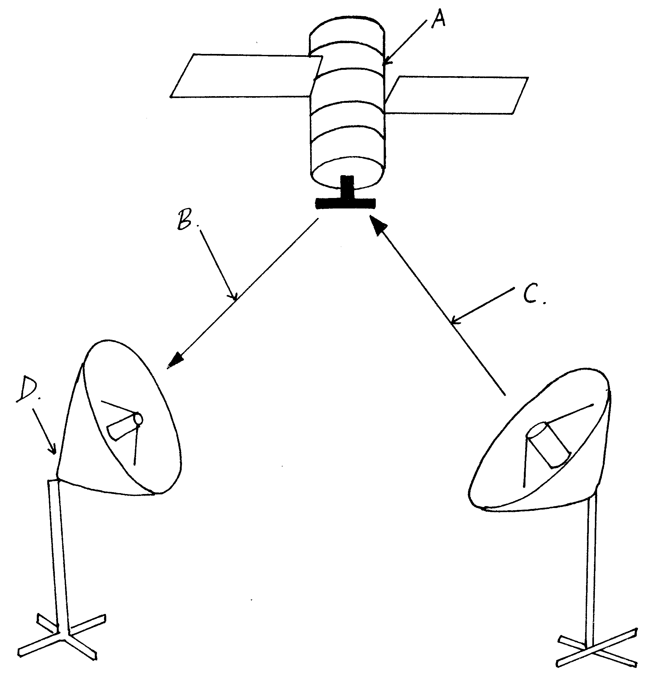
(ii) Give names to the parts indicated by A,B,C,and D. 4mks
(iii) List three advantages of the communication media above. 3mks
b) Explain the three major types of computer networks. 3mks
c) Explain the purpose of the following on a network. 4mks
- A hub
- A switch
- a) Describe any three mouse techniques/skills 3mks
b) List four key groupings on a computer keyboard citing two examples in each. 4mks

c) Name and explain the function of the following key symbols.
i) 2mks

ii) 2mks

iii) 2mks

iv) Esc 2mks
- i) Define the following terms:
          - Data processing. 2mks
          - Data processing cycle 2mks
ii) Describe any two-transcription errors. 4mks
iii) State 3 data processing methods. 3mks
iv) Distinguish between a logical file and a physical file. 4mks
20. a) What is desktop publishing?. 2 mk
b) Explain the function of the following tools. 6mks
i) Hand
ii) Constrained line
iii) Cropping
c) Give three nonprinting guides used in PageMaker. 3mks
d) Describe how you can automatically kern a pair of characters. 4mk

MARKING SCHEME
SAMPLE PAPER 3
451/1
SECTION A. ( 40 MKS)

- - Input devices
  - Output devices
  - Processing devices
  - Storage devices
  - Connecting devices
- This is the preparing of a disk to store information / data ( 1mk)
- a)
( 1mk)
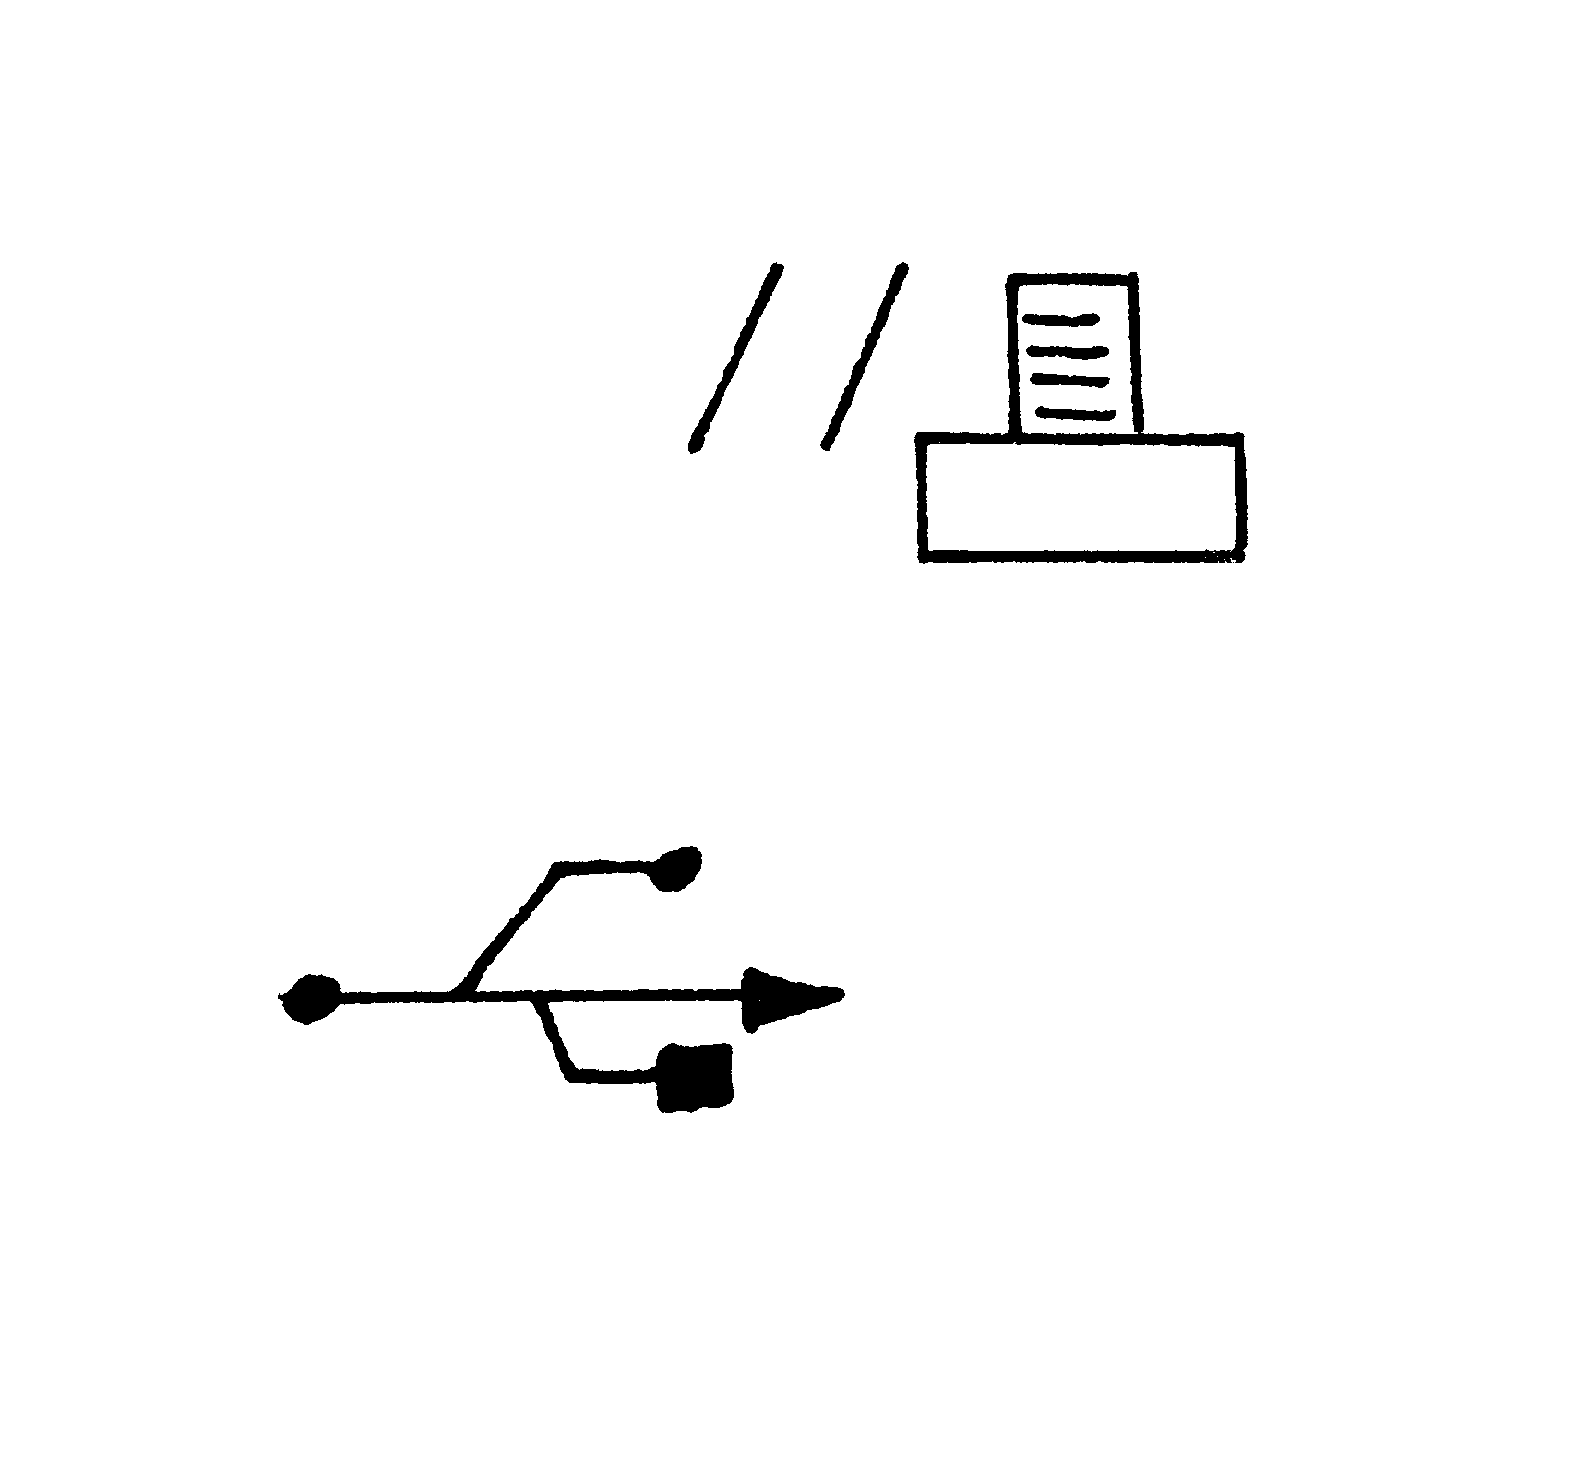
b)
(1 mk)
- Start button- this is on the extreme left end with a word start together with a Microsoft logo. It is used to access programs as well as shut down the computer.
Task Manager – this is the middle part of the bar which displays any task / program that is running
System tray- this is the right most part which bears the system clock

- LCD – Liquid crystal display
EL – Electro Luminescent
Gas – plasma
TFT – Thin film transistor

- a) Real data type is a number with a fractional part / a decimal part while an integer is a whole number without a fractional part
- b) A source code is the program code written in a certain programming language which is yet to be compiled / translated, whereas an object code is the binary translation achieved after compiling a source code.
- - Straight changeover
  - Parallel changeover
  - Phased changeover
- - Number of people / users it can support at a given time
  - Number of tasks / activities it can run at a given time
  - The kind of interface it presents to the user

- i) Automatic carry over to the next line of a word that does not fit at the end of a line hence
avoiding breaking up of words
ii) A feature used to enlarge the first letter of a paragraph so that it drops to cover 2 to more
lines in the paragraph.

2 | 45✓ | 1
2 | 22 | 0
2 | 11 | 1
2 | 5 | 1
2 | 2 | 0  ✓
2 | 1 | 1
✓
Hence 45₁₀ 101101₂

- a) A formular is constituted / constructed by the user while a function is a ready to use formular
that comes with the program .
b) It counts the number of occurrences of the word “Eggs” in the range A10 to E10.

c) This is a key which explains the colour used in charts what it means. (Clear explanation 1mk)
- a) -Flat files
  - Hierarchical model
  - Network model
  - Relational model
- Object oriented model.
- Format- determines the order information appears on the screen / printed.
Default value- a value that appears automatically in the datasheet or form if nothing is entered by the user.
- a) Adobe Page Maker
  - Corel Draw
  - Microsoft Publisher
- Ventura
- A paste board is a large blank area where you place text and any graphical objects for the purpose of rearranging them neatly before placing them on the printable area.
A printable area looks like a page surrounded by margins found on the pasteboard. Any text or object found / placed here will be printed out.

- - .edu – Educational institutional
  - .org- Non – profit making organization
  - .gov- Government institution
-.co- Commercial institution.
- A set of rules that govern how two computers can send and receive data on the network.

SECTION B ( 60MKS)
(Question 16 and any other 3 questions)
- a)
Start

- Correct symbols 3 mks

- Correct use of arrows 1 mk
Age

- Correct labeling 4 mks
Total 8 mks*Tso*

No
Age ≥ 18?

Young
Yes
Adult

End

b) Looping executes the same block of code( module) again and again until a certain condition is fulfilled,while selection execution of a statement(s) depends on a condition that returns true or false ( yes / No) (well explained 2mks)
c) i) Documentation
ii) Testing and Debugging
- Program Design
iv) Implementation
d) - Assemblers
- Compilers
- Interpretors
17. a) i) Satellite ( 1mk)
ii) A – satellite in space
B- Downlink
C- Uplink
D- Receiving earth station
- -Eliminates the need to keep on moving the parabolic dish in a bid to track the line of sight.
  - It offers a large constant line of sight to earth stations
  - The satellites transmits the signal to many recipient earth stations forming a point-
to multipoint transmission.

- - LAN
  - MAN
  - WAN

- i) A hub also called a concentrator connects computers on a network enabling the relay of signals from one computer to another on the same network.
  - A switch forwards a packet directly to the address node ( a data terminal equipment e.g. work station) without broad casting.
18. a) - Pointing
- Clicking
- Double clicking
- Drag and drop

b) Group Example
Function Keys F1, F5
Number Keys 1, 9
Alphabet Keys A, Z
Special Keys Esc, Enter
Screen Keys Pg up, scroll lock
Numeric key pad NumLock, 1

- i) Enter – Used to execute commands
  - Used to move the cursor/ insertion point to the next line
  - Shift - Used to access the uppercase characters.
- Used together with direction keys to select/ highlight characters or cells
  - Tab – Used to move the cursor/ insertion point to tab points( settings) / from field to field
  - Escape – Used to quit/ exit certain operations
19. a) i) Transforming of raw facts to finished and wanted information
b) Stages through which data passes before if becomes the finished and wanted information and
in the form wanted.
- - Misreading
- Transposition
- Manual data processing.
Mechanical data processing
Electronic data processing
- A logical file is a type of file viewed in terms of what data items it contains and details of what processing operations may be performed on the data items, while a physical file is one that is viewed in terms of how data is stored on a storage media and how the processing operations are made possible.
20. a) The process of producing publications like cards, newspaper etc by designing their text and graphic layout, then inserting those text and graphics, editing them, formatting them and printing using a special software.
b) i) Used to scroll the page or to preview and test hyperlinks
ii) Draws either vertical or horizontal lines
- Trims imported graphics to remove unwanted parts.
c) - page margins
- Column guides
- Paste board guides
d) i) Select the text you want to kern
ii) From Type menu, click Expert kerning
- In the dialog box, click the appropriate slider button to make the text tighter or looser.
- Click OK to apply.

SAMPLE PAPER 4
COMPUTER STUDIES PAPER 1
451/1

SECTION A (40 marks)
Answer All Questions In This Section.

1. Name TWO computer crimes. (1mk)
2. Give an example of the following:
- Keying device (1mk)
- Pointing device (1mk)
- Scanning device. (1mk)
3. Give TWO reasons why operating systems were developed. (2mks)
4. List THREE things which accompany newly purchased software. (3mks)
5. A printer fails to work as expected when a document is sent to be printed. The user has checked that the on-line light of the printer is on and the printing paper is correctly inserted. Give TWO other possible reasons why the printing process failed. (2mks)
6. Explain the difference between serial and parallel data transmission. (2mks)
7. Programmers use programming languages to write programs. Based on this statement, distinguish between the following terms as applied in programming.
a). Source code and an object code. (1mk)
b). Machine language and assembly language. (1mk)

8. Computer hardware components consists of control unit(CU), main memory(MM), arithmetic and logic unit(ALU), secondary storage devices, input and output devices. Study the diagram below and answer the question that follow.
MM
D
ALU
B
C
A

Name the parts labelled A, B, C and D. (2mks)
9. Assuming that data is being transmitted using odd parity ASCII system, what could you deduce if each of the following bits are received?
a). 10100101 (1mk)
b). 10111001 (1mk)
10. a). What is a secondary storage device? (1mk)
b). Give THREE reasons why DVD’s are increasingly being used today. (3mks)
11. a). Explain the following features as used in word processing.
i). Word wrap (1mk)
ii). Thesaurus (1mk)
b). The first column in the table below contains the formula stored in cell C10 of a spreadsheet. Enter the formulae as they would appear when copied to cell F15 of the same spreadsheet.

(3mks)
FORMULA IN C10 | FORMULA IN F15
=A5*B5
=A$5
=4*B$6

12. Give THREE responsibilities of a systems analyst. (3mks)
13. a). What is meant by the term tele-working? (1mk)
b). An organization intends to install tele-working in its operations. List THREE disadvantages that are likely to be encountered. (3mks)
14. a). Name the stage of systems development life cycle where an interview is used. (1mk)
b). State TWO advantages and TWO disadvantages of using interviews at the stage in 14(a) above.
Advantages (1mk)
Disadvantages (1mk)
15. a). Give TWO examples of desktop publishing software. (1mk)
b). A computer teacher at St. Joseph’s Girls High School tells students to always ensure that computers are connected to uninterrupted power supply. List TWO reasons why it’s necessary to have this device in a computer lab. (1mk)

SECTION B (60 marks)
Answer Question 16 and any other three questions from this section.

16. A programmer uses program design tools to design a program that can list the odd numbers between
0 and 100.

a). (i). Write a pseudo code for this problem. (5mks)
ii). Draw a flow chart for the pseudo code in 16 a) (i) above. (6mks)
b). Name FOUR data types used in structured programming. (4mks)
17. a). (i) Define the term information system. (1mk)
(ii) Differentiate between a closed system and an open system in relation to system boundary.
(2mks)
iii). Outline the stages of systems development life cycle in their logical sequence briefly describing what takes place at each stage. (7mks)
b). i). A user wishing to access the internet may use a modem or an ISDN connection. What is the purpose of a modem? (1mk)
ii). Explain why using an ISDN connection to the internet eliminates the need for a modem.
(1mk)
iii). State THREE forms of communication that can be transmitted by an ISDN line. (3mks)
18. a). (i) What is data privacy? (1mk)
ii). Give FOUR provisions of the Data Protection Act of 1984 regarding personal data. (4mks)
b). List FOUR factors to be considered when choosing a data processing mode. (2mks)
c). (i) What is an expert system? (1mk)
ii). State TWO advantages and TWO disadvantages of using expert systems.
Advantages (2mks)
Disadvantages (2mks)
d). Explain the following terms as applied in internet communication.
i). Search Engine. (1mk)
ii). Uniform Resource Locator (URL) (1mk)
iii) Domain name (1mk)
19. a). List TWO characteristics of good information. (2mks)
b). (i). What is a database management system? (1mk)
ii). State and explain THREE database models. (3mks)
c). Describe the following types of files.
i). Master file. (2mks)
ii). Backup file. (2mks)
iii). Transaction file. (2mks)
d). Explain the file organization methods given below.
i). Serial. (1mk)
ii). Indexed sequential. (1mk)
iii). Random. (1mk)
20. a). Explain what is achieved by the following Dos commands. (2mks)
i). C:\>TYPE Class.dat
ii). C:\>DEL *.Doc
iii). A:\>COPY *.* C:\PRACTICE
iv). D:\>DIR M*.EXE
b). (i). Identify and explain TWO types of network topologies and for each, give TWO advantages it has for its users. (6mks) ii). Convert 39.75₁₀ to binary. (4mks)
c). State and explain THREE types of program translators. (3mks)

MARKING SCHEME
SAMPLE PAPER 4
451/1
SECTION A

- Fraud, Trespass, Hacking, Piracy, Sabotage, Theft of data ( ½ x2 marks)

2. a) Keyboard, Key- to- disk, Key- to- tape (1x1=1)

b) Mouse, Light pen, Joy stick (1x1=1)

c) Scanners, Wand, Mick, OCR, OMR (1x1=1)

3. - To increase through put
- To improve communication between the user and the computer
- To decrease down time by displaying error messages
- To decrease job set up time
(1x2=2)

4. - License agreement
- Warranty
- User manual
- Reference guide
- Quick reference guide (1x3=3)

5. - The printer not being set to default
- A problem with the picking of papers
- Configuration of the printer to a wrong port (1x2=2)

- In serial transmission, bits are send one at a time over a single transmission line from source to destination while in parallel, a group of bits are send at once over separate lines (1x2=2)

7. a) Source code refers to the program in its original language either assembly or high
level while object code is the machine code equivalent ( ½ x2=1)

- Machine language represents data and instruction in binary codes while assembly language uses mnemonic codes to represent a computer operation
( ½ x2=1)

8. A- Secondary storage device
B- Control Unit ( ½ mark each )
C- Input Device
D- Output device

9. a) An error occurred during transmission as the total number of ones received are an
even number (1mk)

- Transmission had no errors since the total number of ones form an odd number (1mk)

10. a) - An external storage device not part of the computers CPU
- A device that stores data permanently off the computer (1x1=1)

b) - Prices have come down
- Larger storage capacities
- Affordable prices for DVD drives (1x3=3)

11. a) i) Word wrap is a feature which enables text to automatically flow to the next line if the end of the current one is reached (1mk)

- Thesaurus is a feature used to find synonymns and antonymns( 1mk)

b)

1 mk
1mk
1mk
FORMULA IN C10 | FORMULA IN F15
=A5 * B5 | =D10 *E10
=A & 5 | =D&5
=4 *B&6 | =4 *E&6

12. - Design a new system
- Teams up with programmers to ensure smooth coding
- Guides users on how to use the new system
- Carries out system review and maintenance (1x3=3)

13. a) Employees working from home through interlinked computers other than going to
office
(1mk)
b) - Management may fear difficulties of controlling a work force that is not in
office
- It is difficult to ensure that the involved staff fully understands the goals of the organization and be loyal to it
- Employees may feel isolated and miss the social working environment
- It is difficult for employees to work in teams or even find help
- Some teleworkers may find it difficult to separate home from work (1x3=3)

14. a) - Investigations and fact finding (1mk)

- Advantages
  - Information collected is reliable and accurate
  - It is a good method for intensive investigation
  - Questions can be rephrased instantly for clarification
  - Non- verbal communication like facial expressions can be used and observed
( ½ x 2=1)
Disadvantages
  - Requires a lot of expenses and time
  - The interviewee may be reluctant to answer some questions
  - Interviews are difficult to prepare and organize ( ½ x 2=1)

15. a) - Corel draw, Adobe page maker, Ms publisher ( ½ x2=1)
b) - To act as a power backup
- Acts as a surge protector
- Enables computer users to save their work and close down the computer
correctly in the event of power break down ( ½ x2=1)

SECTION B
16. a) i) Start Marks award
Odd=1 * Start/ stop – 1 mk
Repeat Repeat/ until -1 mk
Write odd correct statements -3 mks
Odd= Odd+2 *Also accept use of other control statements
Until odd =99 such as while…DO
Stop
ii)

Start

Odd = 1

Stop

Write odd
Odd = odd + 2

Odd ∠ 99
NO

YES

1 mark for each correct symbol and procedure in the symbol (1x 6=6)

b) - integer, Real, Char, String, Boolean
(1x 4=4)

17. a) i) An integration of both manual and computer based processes that
produce information to support decision making (1mk)
- A closed system is one that is isolated from its environment and therefore
does not interact with it while an open system is one connected to and interacting with its environment (1x 2=2)

- Stage I Preliminary survey/ study
Stage during which a problem is recognized, defined and a feasibility study initiated

Stage II Investigation and fact finding
A comprehensive study is undertaken to establish facts which relate to the proposed system

Stage III Analysis
A stage during which detailed requirements for the new system are identified by the system analysts

Stage IV System Design
At this stage, the proposed system is designed using design trols such as flow charts

Stage V System Construction &Testing
Programs are coded and tested together with the other system components

Stage VI System implementation
This is the stage at which the new system is put to use

Stage VII Maintenance and review
During this stage, repairs, modifications and corrections are done to the implemented system to keep it functional
(For each stage, ½ mk for identification ½ for explanation
b) i) To convert digital signals to analog signals and vice versa during data transmission
( 1mk)

ii) An ISDN line is capable of automatically accepting and converting digital signals to analoge before transmission ( 1mk)
iii) Voice, sound, pictures, text (1x3=3)

18. a) i) The act of making individual data accessible only to its owners and those permitted (1mk)
ii) - Should be obtained and processed fairly and lawfully
- Personal data should be held for specified purposes
- Should not be used for any other reason other than the original purpose
- Personal data should be relevant and adequate
- Should not be kept longer than necessary (1x4=4)

b) - Time when information is required
- Costs involved in implementing the processing method
- Nature of business
- Size of business ( ½ x4=2)

c) i) A computer program which performs tasks that would otherwise require skills of
a human expert if done by people (1mk) Advantages
- The knowledge is always available
- It works faster
- Its decisions are based on logic and issues of emotions does not arise (1x 2=2)

Disadvantages
- It is flexible as it may not take into account exceptional circumstances
- Human experts using it may tend to be over reliant on it
- Expensive to buy, install and maintain (1x2=2)

d) i) A program that enables one to search for particular information on the internet (1mk)
ii) Specifies standard addresses for web pages or other devices on the web or internet
(1mk)
iii) Specifies the name of the file server on which the web resource is held(1mk)

19. a) - Relevant to its purposes
- From reliable source
- Correct, accurate and complete
- Communicated to the right person and at the correct time (1x2=2)

- i) A program that manages the storage, manipulation and access data from the data base (1mk)

ii) Network: Data is represented as a collection of records and relationships joined by links
Hierarchical: Data and relationships among data are represented by linked records which
are organized as a collection of trees
Relational: Data is held as a collection of tables
Files: Data items are stored sequentially in one large file (1x3=3)
( Stating ½ mk
( Explaining ½ mk
c) i) A file that holds permanent data in an organization against which transactions are
processed (2mks)
ii) A file created from existing master files to store duplicate copies that can be used
to restore the original file in the event of loss or damage (2mks)

iii) A file that holds temporary incoming and outgoing data in an organization for a given
period of time (2mks)

d) i) Records are written onto the disk in the order in which they come with no
regard for sequence (1mk)

- Records are arranged on disk in sequence with an index added for easier access
(1mk)

iii) Records are arranged on disk randomly with no obvious relationships among them (1mk)
20. a) i) Displays contents of the file class data on the screen
ii) Deletes all files with Doc extension from drive C
- Copies all files from drive A irrespective of their file extensions to a directory in drive C called PRACTICE
- Displays all files in drive D whose names begin with M and have extension EXE ( ½ x4=2)

b) i) Choose any two from the following
Star topology: Individual work stations are connected by point-to-point link to a central computer (1mk)

Advantages
- If a cable for one computer fails, it does not affect the rest
- Performance is consistent even if the network is being heavily used
- Easier to add new work stations
- Passing of messages within the network is more
- Secure (1x2=2)

Bus topology: All work stations on the network share the same transmission medium called a bus (1mk)

Advantages
- Relatively cheaper and easier to install as it requires the least amount of cable
- Easier to add new work stations without disrupting the network
- Failure of one computer does not affect the others on the network
(1x2=2mks)

Ring topology: A series of computers are connected together by point-to-point links in a closed loop (1mk)
Advantages
- There is no dependence on a central server
- Transmission of messages is simple as they move in one direction
- Very high transmission rates are possible
- Signal degradation is minimal due to the use of repeaters (1x2=2)
ii) Conversion of 39₁₀ -100111₂ (1mk)
Conversion of 0.75 -0.11 (2mks)
Correct answer 100111.11₂ (1mk)

c) Compiler: Translates a program written in a high level language to its machine code equivalent

Assembler: Translates a program written in assembly language to its equivalent machine code

Interpreter: Translates and executes high level language statements immediately they
are encountered (1x3=3)

SAMPLE PAPER 5
COMPUTER STUDIES PAPER 1
451/1
SECTION A (40 MARKS)
Answer all the questions in this section.
Lower = count +1 limit
SUM = SUM + N
N
COUNT < =10?
No
Yes
sum
Count =lower limit

- Write a pseudo code for the above flow chart. (2 mks)
- Differentiate between optical and magnetic scanning techniques used for input and give two examples in each case. (2 mks)
- Name the three main types of human computer interface. (1 ½ mks)
- Distinguish between a folder and a subfolder. (1 mk)
- Draw an illustration of a USB port and explain its function. (2 mks)
- Differentiate between parallel and serial port interface cables. (1 mk)
- a) Explain the following storage disks
  - Zip disks
ii) Jaz disks 1 mk
b) Give four examples of optical disks. (2 mks)
- What do you understand by the following terms: 1 ½ mks
  - Industrial espionage
  - Eaves dropping
  - Surveillance
- a) Differentiate between the following: 1mk
  - surf/browse
ii) Hyperlink
b) Explain two functions performed by the UPS (1 mk)
- a) List three data processing methods. (1 ½ mks)
b) Define the term internet. (1 mk)
c) List four services offered by internet. (2 mks)
- a) State three communication methods without cables. (1 ½ mk)
b) Differentiate between fourth generation languages and third generation languages. (1 mk)
- a) Using twos compliments work out 15₁₀ - 8₁₀ (2 mks)
b) Differentiate the following terms:
i) Source program.
ii) Object code
iii) Translator
1 ½ mks

- Windows operating system provides the use of tool to help in managing storage devices and media. Distinguish between the following terms: 1 ½ mks
  - Disk defragmenter.
  - Partitioning a disk
iii) Compressing.
- a) Give two reasons for partitioning a disk. 1 mk
b) List two main types of desktop publishing software. 1 mk
c) Name any four database models. 2mks
- a) Differentiate between functions and formulae. 1mk
b) Name four basic types of data used in a spreadsheet 2 mks
c) Differentiate between: 1 ½ mks
i) Cell referencing
ii) Relative references
iii) Absolute referencing
d) What is data integrity? ½ mk
e) Differentiate between the following errors: 1mk
i) Transcription errors
ii) Transposition errors
f) The following methods are used in data protection. Explain. 2 mks
i) Audit trail
ii) Data encryption
iii) Log files
iv) Fire walls
SECTION B (60 MARKS)
Answer question 16 and any other three questions from this section
- a) Baraka wholesalers has two categories customers for order processing. Category ‘A’
obtains 10% discount on all orders up to ksh 10,000 otherwise the discount is 20% on the entire order. Category ‘B’ obtains 30% discount on all orders if the debt repayment is ‘good’ otherwise the discount is 15%.Draw a flow chart for the order processing. 8 mks
b) A form four class sat for an exam in eight subjects. A student must get an average of 50% in
all subjects in order to pass. A report is required that will show the name, marks obtained by each student per subject, the average mark and whether the student has passed or failed. Draw a flow chart for this report. 7 mks
- a) Define the term network topology. 1mk
b) Name three different types of computer network topologies. 3 mks
c) Outline any four functions of network operating systems. 4 mks
d) Explain the following as used in internet services 3 mks
i) E- mail
ii) E- commerce
iii) E- learning
- Piracy means making illegal copies of copyrighted software, information or data.
Outline any four ways in which the copyright law can help to reduce piracy4 mks
- a) Define the term data communication. 1 mk
b) Explain the following terms as used in data communication. 2 mks
i) Bandwidth
ii) Attenuation
c) Explain the following three types of computer networks 3mks
i) LAN
ii) MAN
iii) WAN
d) i) What are robots. 1 mk
ii) Outline any four advantages of using robots in industries over human beings. 2 mks
e) Describe the following communication modes giving an example in each case. 6 mks
i) Simplex
ii) Full duplex
iii) Duplex
- a) Describe the following careers in the computing field. 3 mks
    - Computer Engineers
    - Software engineers
    - Computer technician
b) Identify any three duties of an information system manager. 3mks
c) Giving an example, mention three categories of places where you can advance your computer
skills after sitting for your K.C.S.E. 3 mks
d) Mention any four formatting features used in Ms Word application. 2 mks
e) Define the term electronic spreadsheet. 1 mk
f) Explain the following terms as used in Ms Excel spread sheet package. 3 mks
i) Range
ii) What if analysis
iii) Automatic recalculation
20. a) Define the term information system. 1 mk
b) Outline three circumstances under which an organization may want may want to develop
a new information system. 3mks
c) List down any six characteristics of a system. 3 mks
d) Describe the term data processing. 1 mk
e) Outline five qualities of good information. 2 ½ mks
f) List three file organization methods in a computer. ½ mk
g) Briefly describe the following type of computer files. 3 mks
i) Master file
ii) Transaction file
iii) Back up file

MARKING SCHEME
SAMPLE PAPER 5
451/1

SECTION A 40MKS

- For count – 1 to 10 Do
PRINT “ Enter a Number (N)’
INPUT N
Sum = Sum + N
END FOR
Display sum 2mks
Optical
- These types of scanners capture data using light
A special type of concentrated beam of light is passed over the object, image or text which need to be entereed inside the computer. The scanner converts it into digital form example
Optical mark recognition (OMR)
Optical bar recognition (OBR)
Optical character recognition (OCR) (1mk)

Magnetic scanner
Capture data by using magnetic technology
i.e. magnetic ink character recognition (MICR)
Magnetic strip recognition (1mk)

- Command line interface
Menu driven interface
Graphical user interface ½ mk each

- A folder is a named storage area where the user can store related files to enable easy access
½ mk*UG*
Sub folder – this is whereby a large folder is divided into smaller units called subfolders
Subfolder is within another folder ½ mk

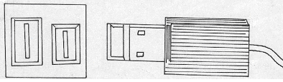

USB port and its interface
USB is set to replace the convectional parallel and serial cables and port
It provides very high speed and quality data transmission over distance by approximately 5 meters
2mks
- Parallel cables transmit information simultaneously using a set of many conductors (wires)
½ mk
Serial cables transmit one bit at a time ½ mk

- Zip disks
They are high capacity disks that resemble the floppy disks. They are slightly larger and thicker in size .It can hold as much as 250MB ½ mk
Jaz disks
They are small portable disks with high storage capacity of about 1 GB to 2Gb.They are used to store data that require large storage

- Lc- 120 super disk (SD)
Digital versatile disk (DVDs)
Optical card
Optical tape
½ mk each
8. i) Industrial espionage – Spying on your competitor to get information that you can use to counter or finish competitor. The aim is to get ideas on how to counter by developing similar approach or sabotage. ½ mk
- Eavesdropping
-Tapping into communication channels to get information ½ mk
- Surveillance
This is keeping of a profile of all computer activities done by another person ½ mk

9. (i) Surf / browse- It is the process of accessing internet resource like the web page and website
- Hyperlink
It is a text on picture on an electronic document especially webpage that cause other web pages to open when the link is clicked ½ mk

b) i) It regulates power from a unstable power source to the required stable voltage by eliminating surges and blow outs ½ mk

ii) It temporarily provides power to the computer in case of sudden power failure ½ mk

10. i) Manual
ii) Mechanical
iii) Electronic ½ mk

b) Internet is a large network of networks that covers the whole world and enables millions of computers from different organizations and people to communicate globally 1mk
c) World wide web
Electronic mail
Electronic commerce
Electronic learning ½ mk each

11.a) Microwave
Satellite
Radio transmission ½ mk each

- Fourth generation
Make programming an easier task by presenting the programme with more programing tools i.e. buttons, form e.t.c The Program selects graphical objects on the screen called control and uses them to create design or a base form .Also application generator can work behind the scene to generate necessary code. ½ mk

12.a) ¹⁵₁₀ - ⁸₁₀ binary form

Count ⁸₁₀ to its binary equivalent
Then write its twos compliment

00001000= 11110111 once compliment

Twos compliment = 11110111 + 1 =11111000 ½ mk

Add the twos compliment to the binary
Equivalent of ¹⁵₁₀ = 00001111₂ ½ mk

Add

00001111 + 11111000 = (1) 00000111₂ ½ mk

(overflow bit ingnore it)

Therefore ¹⁵₁₀ - ⁸₁₀ is a positive number

00000111₂ = ⁷ ₁₀ Ans ½ mk
Total 2 mks

- b) Third generation
Also called structure or procedural. It makes it possible to break a program into components called modules each performing a particular task ½ mk
12. b) i) Source program
Refers to the program code that the programmer enters in the program editor window that is not yet translated into machine readable form ½ mk

Object code
Refers to the program code that is in machine readable ½ mk
Translator
Refer to language processors such as assembler, interpreters and compilers that counts the source program into object code ½ mk

13. Disk Defragmenter- It is a tool used to rearrange scattered folder and files on a storage media in order to speed up access to files and folders ½ mk
Partitioning a disk- Refers to the process of dividing a large physical disk into two or more portrons called logical drives, and then they can be accessed as if it is a separate disk thus creating more space.
½ mk
Compressing
Compressing storage media contents to fit in smaller space helps to create more free space on the media
½ mk
14.a)1. When the user intends to install more than one operating system on the same disk install each other on a separate partition ½ mk

2. For the purpose of backup on the same disk but different function, so that if one partition fails, the others will be still working ½ mk

- Graphical based ½ mk
Layout based ½ mk

- Flat file
Net work
Hierachical
Relational ½ mk each

15.a) Functional are inbuilt predefined formula that the uses quickly uses instead of having to create a new one each time a calculation has to be carried out ½ mk
Formular are user defined mathematical expressions that create relationship between cells and return a value in chosen cells ½ mk
- Lables
Values
Formulae ½ mk each
Functions

c)i) Cell referencing
It identifies a cell or a range of cells on the worksheet and shows Microsoft Excel where to look for the value, or data needed to use in a formulae ½ mk

ii) Relative
This is when performing tasks that require referencing, you can use formulae whose cell referencing keep on changing automatically depending on their position in the worksheets. ½ mk

iii) Absolute referencing
These are cell references that always refer to cells in a specific location of the worksheet cell if they are copied from one cell to another ½ mk
- Data Integrity
Refers to the accuracy and completeness of data entered in a computer or received from the information system .It is measured in terms of accuracy, timelines and relevance of data ½ mk
- Transcription errors
Occur during data entry such errors include misreading and transposition error ½ mk
Transposition errors
Incorrect arrangement of character i.e. putting characters in the wrong order 396 instead of 36g
g)i) Audit tail
This is a careful study of an information system by experts in order to establish or find out all the weakness in the system that could lead to security threats and weak access point for orimestews ½ mk
ii) Data encryption
This is protection of data from being tapped listened or copied by mixing if up into a form that only the sender and receiver can be able to understand ½ mk

- Log files
This are special system files that keep a record (log) of events on the use of the computers and resources of the information system ½ mk
- Fire walls
This is a device or software system that filters the data and information exchanged between different networks by enforcing the host networks access control policy. The aim is to monitor and control access to or from protected networks ½ mk

SECTION B 60 MKS
16.a) Flowchart (8mks)
Start

Read category

Category = A ?

Y N N N Y Y (7mks)
Order ≤ 10,000 ?
Repayment = Good ?
Stop
Read order
Read repayment
Disc = 0.3 x order

Print order discount
Disc = 0.15 x order
Disc = order x 0.1

Disc = 0.2 x order

7 mks
Get student name

Get student marks

Start
Completed All Student?
Average
> 50%
End
Start
Calculate Average
Print report
Print pass

No Yes Yes
Print fail
NO
- Network topology
- Refers to the way in which computers and other devices have been arranged or how data is passed from one computer to another in the network (1mk)

b) Types of computer network topologies
- Star topology
- Bus topology
- Ring topology
- Mesh topology
- Tree / therarchical topology (1 x 3mks)
c) Fucntions of network operating system.
- Provides access to network resources
- Supports interprocess communication
- Enables nodes on the network to communicate with each other more efficiently
- Respond to requests from application programs running on the network
- Support network services like network card drivers and protocols
- Implementing networks security features (1x 4 mks)
d) i) E-mail
- This is the exchange of electronic letters, data and graphics on the internet (1mk)
ii) E-commerce
- This is a business strategy where goods and services are being sold over the internet .
- There is no physical, interaction between seller and buyer (1mk)
iii) E-learning
- This is learning through interaction with special programs on the computer.(1mk)
e) Ways of reducing piracy
- Enact laws that protect the owners of data and information against piracy
- Make software cheap enough to increase affordability
- Use licenses and certificates to identify originals
- Set installation passwords that deter illegal installation of software (1x4)
18.a) Data communication
- Refers to the process of transmitting data signal from one point to another through the network (1mk)
b) i) Bandwidth
- This is the maximum amount of data that a transmission medium can carry at any one time (1mk)
ii) Attenuation
- This is the decrease in magnitude and energy as a signal progressively moves along a transmission medium. (1mk)
c) i)LAN
- Local area network is a computer network that spans a relatively small geographical area like in one building or a school. Usually owned by an organization (1mk)
ii) MAN
- Metropolitan area network is a network that cover a medium – size geographical area like a town or a city
- They cover a radius of approximately 10km and have data rates of 100 mbps (1mk)
iii) WAN
- Wide area networks cover unlimited geographical areas e.g. across states, entire country or the whole world.
- Consists of many LANS and MANS connected together (1mk)

- What are robots
- Robots computer controlled devices usually in form of mechanical and are used to manipulate objects (1mk)
- Advantages of Robots
- They do not make mistakes i.e. They are accurate
- They work under hazardous conditions
- They can perform a wide variety of tasks
- Are quite efficient
- Work tirelessly for long hours
- Are quite fast ½ mk each (2mks)
e) i) Simplex
- A transmission mode which allows transmission of data in only one direction. There is no immediate feedback e.g. the radio broadcasting (2mks)
ii) Full duplex
- A transmission mode which allows transmission of data in two directions, but only one direction at a time e.g. the police radio calls (2mks)
iii) Duplex
- A transmission mode which allows transmission of data in two directions concurrently e.g. telephone transmission (2mks)
19. a) i) Computer Engineers
- This is a person who is skilled is designing and developing computer components such as storage devices and other electronic components (1mk)
ii) Software Engineers
- This is a person who is skilled in software development and technical operation of a computer hardware. (1mk)
iii) Computer technician
- This are skilled persons who maintain, upgrade and repair computers to ensure that all the devices are in good working condition (1mk)
b) Duties of an information system manager
- Making sure that all tasks in the IT department are done correctly and on time
- Preparing budgets for the departments
- Keeping the department inventory records up-to-date
- Managing the human resource within the department (Any 3 x 1) 3mks
c) i) Universities – Kenyatta, Nairobi, JKUAT, Egerton Universities
ii) Polytechnics – Kenya , Mombasa, Eldoret, Kisumu poly
iii) College – Institutes e.g. Rift valley and private colleges e.t.c (1x3)
d) Formatting features
- Changing fonts (type, style and size)
- Changing text colour
- Underlining
- Bolding
- Italising ( ½ x 4) (2mks
e) Defn. of electronic spreadsheet
- An electronic spreadsheet is an application software consisting of a series of rows and columns that form cells and are used for the manipulation of numeric data (1mk)
f) i) Range
- A range is a rectangular arrangement of cells specified by the address of its top left and bottom right cells, separated by a colon(: ) e.g. (A1: B8) (1mk)
ii) “What if” analysis
- This involves changing the value of one of the arguments in a formula to see the difference the change would make on the result of the calculation
iii) Automatic recalculation
- This is a feature in electronic spreadsheet which automatically adjusts the result of a formula if the values in worksheet are changed (1mk)
20. a) Definition of information system
- An information system is an arrangement of people, data processes and information that work together to support and improve the day-to-day operations in a business and the decision making process (1mk)
b) Reasons for developing a new information system
i) New opportunities- A chance to improve quality of internal processes and services delivery in the organization
ii) Problems – Undesirable circumstances that prevent the organization from meeting its goals
iii) Directives - new requirements imposed by the government, management or external influences
1x3 (1 mk each)
c) Characteristics of a system
- Is made up of various components which must work together as a unit to achieve its overall goals
- Is made up of different sub-systems
- Has a space or boundary within which the components operate.
- Has a particular task to perform
- Transforms or process data from one state to another.
- It decays naturally over time due to improvement in technology
- It communicates with its environment by receiving inputs and giving outputs.
- It can receives input from and gives output to the environment or not. i.e (its either open or closed system) ½ x 6 (3mks)
d) Data processing
- These are activities that are concerned with the systematic recording, arranging, filling, processing and dissemination of facts relating to the physical events occurring in the business using data processing aids such as computers (1mk)
e) Qualities of good information
- Must be relevant for the intended purpose
- Must be accurate and comprehensive
- It is obtained from a reliable source
- It is communicated to the right person and in time
- it is understandable by the user ( ½ x 5) (2 ½ mks
f) File organization methods
- Sequential
- Random
- Serial
- Indexed sequential ( ½ x 3 ) 1 ½ mks)
g) i) Master file
- This is the main file that contains permanent data against which transaction are processed
ii) Transaction file
- Includes input and output files for holding temporary incoming or outgoing data (1mk)
iii) Backup files
- This are files used to hold copies (Backups of data or information from the computer fixed storage (hard disk) (1mk)

SAMPLE PAPER 6
COMPUTER STUDIES PAPER 1
451/1
SECTION A (40 marks)
Answer all questions in this section

- State three classifications of micro computers when classified according to size. (3mks)
- Give three main advantages of using computers for data processing functions over other types of office and business equipments (3mks)
- (a) What is disk partitioning? (2mks)
(b) Give two reasons for partitioning a disk. (2mks)
- Give a reason for each of the following hardware considerations when selecting a computer system (4mks)
  - Processor speed.
- Warranty.
- Upgradeability and compatibility.
- Portability.
- Outline the functions of the following utility software (3mks)
- Loaders.
- Debuggers.
- Linkers.
- Draw a diagram to illustrate the following. (3mks)
- USB Port.
- Serial Port.
- Parallel Port.
- A computer operator in your school wanted to print a document but the printer could not print yet the online light is on and the printer paper is correctly placed. Give the other possible reasons why the printing process failed. (2mks)
- Differentiate between office and magnetic scanning techniques and give two example of each.
(4mks)
- Explain what the following Dos commands achieve when executed.
- C: \ > DIR P *.EXE (1mk)
- A: \ > format (1mk)
- List three main types of human computer interface (3mks)
(i) ....................................................................................................................................................
(ii)..................................................................................................................................................
(iii)…..............................................................................................................................................
- Define the following terms as used in word processing.
  - Word wrap (1mk)
  - Thesaurus (1mk)
- What is telecommuting? (2mks)
- Differentiate the following terms
- Source program (1mk)
- Object code (1mk)
- Define the following terms
    - Data processing (1mk)
    - Data processing cycle (1mk)
- List any four factors to be considered when selecting software. (2mks)
(i) ....................................................................................................................................................
(ii) ..................................................................................................................................................
(iii) ................................................................................................................................................
(iv) ..................................................................................................................................................
SECTION B
Answer question 16 (compulsory) and any other three questions from this section.

- You have been asked by a standard four mathematics teacher to generate a list of even numbers between 0 and 201.

      - Write a pseudocode used to solve this problem. (6mks)
      - Draw a flow chart for the program above. (5mks)
    - List four data types used in structural programming. (4mks)
- (a) Define the following programming terms. (4mks)
      - Machine language.
      - Translator.
    - Outline the change over strategies that can be used to move from manual system to computerized system. (3mks)
(i) ....................................................................................................................................................
(ii) ..................................................................................................................................................
(iii) .................................................................................................................................................
(c) (i) State the stage of program development where an interview is used. (2mks)
  - State two advantages and two disadvantages of using interviews at the stage in C(i) above.
Advantages
(i) ....................................................................................................................................................
(ii) ..................................................................................................................................................
Disadvantages
(i).....................................................................................................................................................
(ii) ..................................................................................................................................................
- (a) What is an expert system? (2mks)
(b) (i) What is a robot? (2mks)
- Outline any four advantages of using robots in industries over human beings. (4mks)
(i) ....................................................................................................................................................
(ii) ..................................................................................................................................................
(iii) .................................................................................................................................................
(iv) ..................................................................................................................................................

(c) Explain the following career opportunities in computing.
- Software Engineers (1mk)
- Computer technician (1mk)
- Computer programmer (1mk)
- System analyst (1mk)
- Give three main categories of higher learning where you can advance your computer skills after O-level.
(i) ....................................................................................................................................................
(ii)...................................................................................................................................................
(iii) .................................................................................................................................................

19. (a) Differentiate between a formula and a function as used in Excel. (2mks)
(b) What is the effect of the following function?
COUNTIF (A5:D5,”orange”). (2mks)
- The first column in the table below contains the formula stored in all C10 of a spreadsheet. Enter the formula as they would appear when copied to cell F15 of the same spreadsheet.
(3mks)
FORMULA IN C10 | FORMULA IN F15
=A56*B5
=A$5
=4*B$6
- (i) Explain the concept of distributed databases. (2mks)
- State two advantages of distributed databases. (2mks)
(e) Outline two uses of forms in database design. (2mks)
(f) List any two word processor software. (2mks)
20. (a) Indicate the method of file access for the following file organization methods. (2mks)

Organization method | File access
(i) Random | (i)
(ii) Sequential | (ii)
(iii) Serial | (iii)
(iv) Index Sequential | (iv)

(b) Use one’s complement to calculate 11101₂ - 101₂ (4mks)
- Convert 0.375₁₀ into binary notation. (2mks)
- Define the term network topology. (2mks)
(e) List any four physical topologies in a network (3mks)
(f) Differentiate between Ethernet and Token Topology. (2mks)
MARKING SCHEME
SAMPLE PAPER 6
451/1

  - Desktop computer
  - Laptop computer
  - Palmtop computer / notebook. (3mks)

  - Computers process data faster
  - Computers are more accurate
  - Computers are more efficient. (3mks)

    - This is the process of dividing a large physical disk into two or more partitions called logical drives (1mk)
    - (i) The user may intend to install more than one operating system on the same disk.
(ii) For purpose of backup on the same disk but different partitions.

  - A good computer must have high processor speed. (1mk)
  - It is important to understand the terms and conditions of after selling a product in case of failure or malfunction that is whether the seller is ready to provide after sales services. (1mk)
  - The best convention would be to buy a computer that can easily be upgraded to accommodate emergent technologies. (1mk)
  - Smaller computer enhances mobility. (1mk)

  - Help in transferring an application from a secondary storage to a primary storage when running the application. (1mk)
  - Help in tracing and removing errors from a program. (1mk)
  - Linkers enable several programs (modules) to subroutines to be connected when running (1mk)

    - 

    - 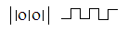

    - 

    - Set a printer as a default.
    - The printer may have been configured to the wrong port.
    - Check the picking mechanism of the paper.
(Award 1 mark for each correct answer)

    - Optical scanners capture data using the principle of light. (1mk)
Examples - Optical mark recognition. (½mk )
- Optical bar recognition (½mk )
- Optical character recognition (½mk)
    - Magnetic scanners capture data by using the principle 2 magnetism.
Examples – MICR (½mk )
- Magnetic strip recognition (½mk )

  - Displays al files in drive D whose names begin with P and have extension EXE. (1mk)
  - Format drive A.

  - Command line interface. (1mk)
  - Menu driven interface. (1mk)
  - Graphical use interface (1mk)

  - It is a feature which enables text to automatically flow to the next line if the end of the current one is reached. (1mk)
  - Thesaurus is a feature used to find synomus and autonymus. (1mk)

- Telecommuting is a term used to refer to a situation where an employee works usually at home using a computer connected to the workplace network. (1mk)

  - Source program refers to the program written in its original language (source code) either assembly or high level. (2mks)
  - Object code is the machine code equivalent. It is the program in compute language. (2mks)

    - Transforming of raw data to finished waited information. (2mks)
    - Stages through which data passes before it becomes the finished and wanted information. (2mks)

- Authenticity
- Documentation
- User needs
- Reliability
- User friendliness
- Cost
- Compatibility and system configurations
- Portability
(Any correct answer award 1 mark)
1 x 4 = 4mks

SECTION B

    - Program Even numbers (input, output):
{Program used to generate even numbers between 0 and 201}
Var
Begin, ½mk
Even = 2 1mk
Repeat 1mk
Write even 1mk
Even = Even + 2 1mk
Until Even = 200 1mk
End. ½mk

* Also accept use of other control structures such as While… DO
    - )

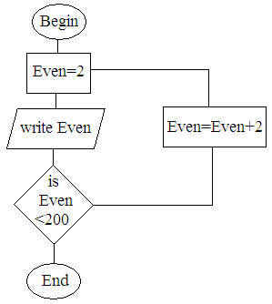
½

1
1

1

1

 ½

    - Give types used in structural programming..

- Real
- Integer
- Char
- String
- Boalean.
- (a)
  - This is a computer language that uses binary digits to represent data and information. (2mks)
  - Refer to language processors such as assembler, interpreter and compilers that translate the source code to object code. (2mks)
(b)
- Parallel changeover. (1mk)
- Direct changeover. (1mk)
- Phase changeover. (1mk)
(c)
- During investigation and fact finding. (2mk)

Advantages
  - Reliable and accurate.
  - Intensive investigation.
  - Questions can be rephrased for clarification.
  - Non.-verbal communication like facial expression can be used and observed.
  - Feedback is obtained instantly

Disadvantages
- Expensive and time consuming.
- Interviews are difficult to prepare and organize.
- The interviewee may be reluctant to answer some questions.
- Subjective.

    - A computer program which performs tasks that would otherwise requires skills of human expert if done by people. (2mks)
    - (i) A robot is a computer controlled device usually in form of mechanical and is used to manipulate objects. (2mks)
(ii)
- They are accurate
- They work under hazardous conditions
- They can perform a wide variety of tasks
- Are quite efficient
- Are fast
- Cannot get tired nor bored.
(Any correct answer award 1mk) 4mks
- (i)This is a person who is skilled in designing and developing computer components.
- (i) This is a person who is skilled in software development and technical operation of computer hardware.
  - These are skilled persons who maintain, upgrade and repair computers to ensure that all the devices are good working condition.
  - This is a person skilled in writing programs in high level language. (1mk)
  - System analyst whose responsibility is to design a new system, team up with programmers to ensure smooth coding and carries out system review and maintenance. (1mk)

- Universities – Nairobi, Kenyatta, JKUAT, Egerton, Moi.
- Polytechnics – Kenya, Mombasa, and Eldoret polytechnic.
- College – Strathmore e.t.c
- Institutes - Kisumu institute, Kabete institute, Kiambu institute, Mombasa institute. (3 mks)

  - Functions are predefined formula that can be used quickly instead of having to create a new one each time a calculation has to be carried out. (1mk)
- Formulas are user defined mathematical expressions that create relationship between cells and return a value in chosen cells. (1mk)
  - It counts the number of occurrences of the word “oranges” in the range A5: DB.(2mks)

FORMULA IN C:10 | FORMULA IN F:15
= A5*B5 | = D10 * E10
= A $ 5 | = D $ 5
= 4 * B $ 6 | =4 * E $ 6

  - This is where database are created for different departments in an organizations in different computers that are networked (2mks)
(ii) - Searching of items is fast. (1mk)
- No interference of other departments data (1mk)
  - - used to enter data into tables.
- Display data from tables and queries.
  - - Ms word
- WordStar
- word perfect etc
For Any word processor package award
1 mark (max = 2mks).
- (a)
- Random- (direct) (½)
- Serial (½)
- Serial (½)
- Direct (½)
(b) 1110₂ - 101₂
Change nuend to 4 digits
101  0101  (1mk)
Find the complement of nuend
0101 1010  (1mk)
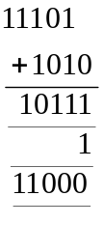 Carry over the overflow  (1mk)

- Convert 0.375₁₀ into binary notation.
Solution:
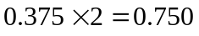  ½
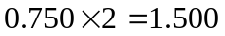  ½
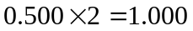  ½ 2mks
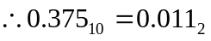  ½

- This is the way in which computer and other devices have been arranged or how data is passed from one computer to another. (2mks)

  - Star topology  (½)
  - Bus topology  (½)
  - Mesh topology (½)
  - Ring topology  (½)

SAMPLE PAPER 8
COMPUTER STUDIES PAPER 1
451/1

SECTION A (40marks)
1. Explain the following terms as used in information Technology with reference
to software purchase:-
i) User friendliness ( 1mk )
Refers to how easy the software is to use for the user.
ii) Authenticity ( 1mk )
The genuinessess , validity and / or legitimacy of the software.
2. In system development testing is one of the critical stages. Give three reasons
why the testing phrase is critical to the systems developer. ( 3mks )
- Helps to ensure that the logical and physical designs and environment are to the users satisfaction
- Helps to detect and correct errors.
- Gives proof to those skeptical about the working of the system
- Helps to establish how the system works under various conditions allowing for full description of the system capabilities.
3. Give three ways in which a magnetic tape differs from a magnetic disk
Magnetic disk Magnetic tape
-Tracks are concentric - Tracks are parallel and located lengthwise
-Move only in one play direction - Move in two directions( forward and
Backwards)
- Do not come in control with the read - Comes in contact with the read/ write
/ write head heed
- Have shorter access time - Have longer access time
- Data accessed by a number of methods - Data accessed only by serial method.
4. Name the three components of a spreadsheet ( 3mks)
- Database
- Graphs
- Worksheet

5. i) What is a page header ( 1mk)
- This are the words at the top of every page of document just above the page margin
ii) Differentiate between a page margin and a page border. ( 1mk )

6. State any two differences between function keys and special keys of a keyboard.
( 2mks )
Function keys Special keys
- Normally used single to execute a task. - Normally used in combination with other
Keys the execute a task.
- Initiate frequently done task to occur - Give special instructions to the computer.

7. i) Give any two differences between margin guides and column guides as used
in desktop publishing ( 2mks)
- Column guides help to divide the pages into columns that make the publication look more organized and are witin a page, a normally pink coloured while margin guides are around the edges of the printable page and are normally blue in colour.
ii) what does the gutter in a word processor mean in relation to column settings? ( 1mk)
8. State any three advantage of using microwaves to transmit data. ( 3mks)
- Operate at a high speed
- Have a huge transmission capacity
- Are less prone to transmission errors
- Are capable of transmitting both digital and analogue signals
- Name any three methods that can be used to test a program of errors (3mks)
- Desk checking ( Dry- run )
- Using debugging utilities
- Using test data.
10. Give any three characteristics of systems ( 3mks )
- Holistic
- Subsystems
- Boundary and environment
- Purpose
- Process
- Syetm entropy
- Inputs and outputs
- Open and closed system
- Control

11. Why is a computer referred to as an electronic device ( 1mk)
It utilizes electronic signals to process information
12. Why is a mobile phone regarded to be a computer ( 3mks )
- electronic device
- having inputs / output device
- programmable
- process date at high speed.

- State any three reason why computers are a much more preferred machine to use
in an office and business than other office machines. ( 3mks )
- computers process data faster
- computers are more accurate
- computers are more efficient ( they utilize minimum resources to process data)
14. State any three factors to consider when preparing a computer laboratory ( 3mks)

- security of programs and other resources
- reliability of the ( source of ) power
- the number of computers to be installed and available floor space
- the maximum number of users that the laboratory can accommodate.
15. state any two functions of a UPS ( 2mks )
- supply power to computers when power abruptly fails temporarily
- clean power to computers

SECTION B
16.a) i) State any two advantage of low level languages. ( 2mks )
- no translation
- processor execute them faster
- are stable and hardly crash down once written
ii) Explain in the following terms as used in high level languages.
Capsulation ( 1mk)
- Having data and functions that operate on the data within an object
Inheritance ( 1mk )
- child module based on parent modules takes on all features of the parent
module.
iii) Give any two examples of fouth generation languages. ( 2mks )
Visual basic, delphi pascal, visual COBOL,

- Draw a flow chart that would be used to design a program that would evaluate the
value of F using the formula F = (5mks)

Start (1mk)

(1mk)

Enter f1 = f₁, f₂ (1mk)

(1mk)
F = = f₁ + f₂
f₁ + f₂

Out put F (1mk)

Stop logic (1mk)

- From the flow chart developed in part ( b) above write a pseudocode to do the same
task as the flow chart ( 4mks )
Begin
Enter the values of f₁ and f₂ (1mk)
Calculate F
(1mk) F = f₁ + f₂ (1mk)
f₁ f₂

Output F - (1mk)
end

17. a) Explain the following computer crime terminologies below
i) Hacking ( 1mk )
- Is breaking into a computer system to look at data, copy or modify data to which the person has no authority to access.
ii) Tapping ( 1mk )
- Getting access to data while in transmission

iii) Cracking ( 1mk)
- Is establishing of week access points in a software by use of guess work or otherwise but normally the cracker has some idea about the system securities.
iv) Piracy ( 1mk)
Making copies of copy righted software / data.
  - Fraud
- Use of computers to conceal information or cheat other users with the intention of making a gain.
iv) Sabotage ( 1mk )
- The illegal destruction of data and information with the aim of cripping service delivery or causing loss to a firm.
vii) Alteration ( 1mk)
Changing of data / information without permission with the aim of gaining or misinforming the authorized users.

b) Piracy is the worst computer crime that is scaring software developers out of their wits. Suggest any ways that can be instituted to reduce to reduce piracy ( 4mks )
- Enact laws that protect developers of software against piracy
- Make software cheap enough to increase affordability
- Use licenses and certificates to identify originals
- Set installation passwords that deter illegal installation of software
- create install once software.
c) State any four measures that can be taken to detect, prevent computer crimes and
seal security loopholes. ( 4mks )
- Audit trail
- Data encryption
- Log files
- Firewalls.
18. a) Network software comes in two main categories. Name them ( 2mks )
- Network operating system
- Network protocol
b) ( i) state any five unique network operating system software functions (5mk)
- Provides access to network resources
- Enable nodes to communicate with each other more efficiently
- Supports network services like network card drivers and protocols
- Implementats network security features.

ii) Name any two network operating systems ( 2mks)
windows NT, linux , Novell, windows 2000, windows 2003, unix.

c) Explain the following advantages of networking
i) Sharing of resources ( 2mks)
The resources include data / information, files printers, software etc.
- Users do not need to transfer data via removable media but sort straight saving on cost.
- Centralized access to data / information leads to less time wastage hence greeter productivity.
ii) Distributed facilities ( 2mks )
- The failure of the central computer does not affect the operations of other terminals
- Processing load is shared equally hence no time wastage and high quality productivity.
iii) Reliability ( 2mks )
- Data can be transferred with minimum error from source to destination
- In use one computer breaks, users can still access data / information from the other computers using another computer using another computer on the network.

19.a) Complete the table below that classifies errors that influence the accuracy of
data input and information output into / from a computer system ( 5mks )

ERRORS

TRANSCRIPTION COMPUTATIONAL ALUOROTHMIC
ERRORS

TRANSCRIPTION MISREADING ROUDING OFF OVERFLOW TRUNCATION
ERRORS

b) Explain what data integrity is by clearly describing its measures ( 7mks )
It is the accuracy and completeness of data entered and information received from on information system.
It is measured by:-
- Accuracy : how close an approximation is to the actual value.
- timeliness : deals with being given at the right time
- Relevance: refer to entered data being pertinent to the processing needs at hand and meeting the requirements of the process cycle.
c) State any three advantages of files using sequential file organization method
- Approach is simple to understand
- Locating a record requires only the record key therefore fast.
- Efficient and economical if the activity rate is high.
- Relatively in expensive input / output media and devices may be used.
20. a) A shopkeeper of a small shop at manga has bought a desktop computer to assist him in performing his business activities. He has been advised that before he can use it to work he has to install it with an operating system. State any six factors to consider when choosing the operating system ( 6mks )
1. Hardware configurations ( memory size, type of processor; speed )
- Basic design of the computer e.g IBM or IBM compatible or apple
- Applications intended for the computer
- User friendliness or human computer interface
- Availability is the market
- Lost
- Reliability
b) With reference to disk management explain what is meant by the terms below.
i) Formatting ( 1mk)
- Preparing disks for data storage by creating sectors and tracks on the disk surface.

ii) Defragmentation ( 1mk)
- The rearrangement of scattered files on a storage media in order to speed
up access to files.
iii) Disk partitioning ( 1mk)
- The process of dividing a large physical disk into two or more portions / logical drives or volumes.
c) Give any two reasons that may make the shopkeeper to partition the computer disk( 2mks)
- In order to install more than one operating system on the same disk.
- In order to be able to make back up on the same disk.
- The shopkeeper one day switched on the computer and experienced a number of problems with windows operating system that he had installed. The problems included failure to load the operating system during the booting. After several trials of switching on the computer booting, it hang so often alongside abnormal restarting. State any four possible causes for the computer’s behaviour. (4mk)
- Hardware conflict or incompatibility possibility due to interrupt requests or missing device drivers.
- Possibility of a problem in the installation process
- Problem with hard disk boot sector due to damage or virus attack
- Insufficient memory
- Corrupted system windows registry.
SAMPLE PAPER 8
COMPUTER STUDIES PAPER 1
451/1
1. What do you understand by the following types of memory?
i. Mask read only memory
ii. Erasable programmable read only memory (EPROM)
(2mks)
2 State one function of the central processing unit (1mk)
3 a) what is a low level programming language. (1mk)
b) How does it differ from a high level programming language. (1mk)
4 a) State two advantages of voice/speech input? (2mks)
b) List down two common ports on a computer system. (2mks)
5 a) What is the difference between character based operating system and graphical user interface operating system (2mks)
b) State two categories of input devices (2mks)
6 List down two factors to be considered when selecting an input device (2mks)
7 List down at least two precaution necessary in a computer laboratory (2mks)
8. The diagram bellow shows coded data that could be input into a computer

761430724973

a) What is the name of the above method of input (1 mk)
b) Where would the above method of input be applied? (1 mk)
c) For the application you have given in the above question, state two items of
information this type of input may represent. (2 Mks)

9. a) Define the term variables as used in programming (Imk)
b) Explain why variables are important in a programme (2mks)
10. Differentiate between baseband and broadband signals as applied to data transmission
(2mks)
11. By using two compliment work out 31₁₀ - 17₁₀ in binary form.
Show your calculations clearly. (2mks)
12 Write brief notes to the following type of errors
i. Algorithmic errors.
ii). Transposition errors (2mks)
13 What is an Internet Service Provider (1SP) (2mks)

14 a) What is word wrap as used in word processing (1 mk)
b) List down examples of word processing packages in the market today. (2mks)
15 a) what are the characteristics of (ROM) (2mks)
b) The diagram below is of a common port in a computer system
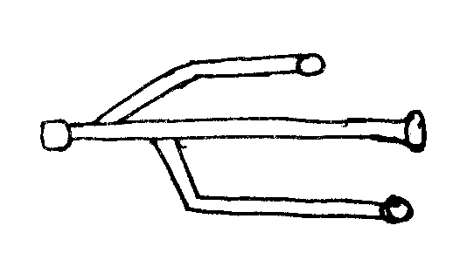

i. What is the name of the port shown above (1 mk)
ii. What are some of the examples of devices that can be connected to the above port?
(2mks)
SECTION B
Answer question 16 and any other three questions from this section in the Answer
sheet provided.

16 a) Define the terminologies;-
i) Source code
ii) Object code (4mks)
b) With an aid of a pseudocode and flow chart, write a computer program that can be used to compare the values of two numbers and print the largest number. (11 mks)
17 a) State any three reasons why people may resist the introduction of computers at their place of work (3mks)
b) Outline other threats facing computers in this modern world. (3mks)
c) State four factors to consider when purchasing a memory for your computer.
(4mks)
d) State three salient features of a computer output (3mks)
e) State the function of the following MSDOS commands
i) REN (1mk)
ii) DIR/P (1mk)
18) a) Distinguish between the following sets of terminologies used in spreadsheets
i) Work sheet and work book . (2mks)
ii) Filtering and sorting (2mks)
b) State one way in which a user may reverse the last action taken in a spreadsheet
package. (1mk)
c) The following is the sample of a payroll. The worksheet row and column heading are
marked 1,2,3.... and A. B, C.... respectively
 | A | B | C | D | E | F | G | H
1 | NAME | HRS WORKED | PAY PER HR | BASIC PAY | ALLOWANCE | GROSS PAY | TAX DEDUCTED | NET PAY
2 | KORIR | 12 | 1500
3 | ATIENO | 28 | 650
4 | MUTIZO | 36 | 640
5 | ASHA | 30 | 900
6 | MULI | 18 | 550
7 | WANJIKO | 22.5 | 500
8 | WANGARI | 24.5 | 250
9 | OLESAN | 17 | 180
10 | MOSES | 33 | 700
Use the following expressions to answer the questions that follow

• BASIC PAY = hrs marked X pay per hr
• ALLOWANCES are allocated at 10% basic pay
• CROSS PAY basic pay + allowance
• TAX deducted are calculated at 20% gross pay
• NET PAY gross pay-tax deducted
Write a formulae using cell reference for the following:
1) D2
2) E4
3) FI0
4) G7
5) H5 (5mks)
d) i) State the ways of editing the contents of a cell in Microsoft excel. (3mks)
ii) State two of how information and communication technology (ict) can be used to reduce the spread of HIV/AIDS (2mks)
19 i) with the aid of a pseudocode and a flow chart design an algorithm that
i. Prompt the user to enter two numbers x and y
ii) Divide X and Y and display the quotient. However if the value of Y is O, the program should display an error message "Error division by zero" (l0mks)
iii) State the major components found in the system unit (CPU) (4mks)
iv) What is programming (1 mk)

20 a) With the aid of a diagram explain the following network typologies
i) Ring topology.
ii) Bus topology,
iii) Star topology (6mks)
b) Define the following terminologies in relation to networking.
i) Crosstalk
ii Noise
- Attenuation
- Frequency (4mks)
c) State two advantages of and two disadvantages of wireless communication (4mks)
d) List down one major advantage of networking. (1mrk)

MARKING SCHEME
SAMPLE PAPER 8
451/1

1. i) Type of ROM once written by the manufacturer its contents cannot be deleted
ii) Type of Rom whole contents may be erased by exposing it to ultra violet light
2. i) To co-ordinate the activities of the computer system during the execution of a program
ii) performing the operations like data transfer arithmentic calculations and decision- making.
- State of instructions and data needed by the program currently being processed
3. a) Programming language that uses binary codes i.e. 1s and 0s
b) A low level programming language uses binary codes as processing codes while
high level programming languages uses mormonics i.e English like statements as instructions.
4. a) - Suitable for handicapped people.
- Fast and easy method
- - Printer port
  - USB port
  - Communication port

5. a) Character based operating system uses commands to execute instructions
while graphical user interface operating system uses icons which are clicked by the use of a mouse.
b) - Keying devices
- Voice recognition input devices
- Pointing devices
- Touch screen
6. - Type of data to be entered into the computer
- Cost
- Speed

7. - No smoking in the lab
- No carying of liquids and eatables
- All windows should be open to allow free air movement
8. a) Optical bar code recognition (OBR)
b) At point of sale terminals e.g. in super markets
c) The bars may contain specific information about the item sold e.g – type of commodity
- Cost
- Quantity
- Manufacturer etc
9. a) A memory location
b) Help especially when one wants to use a specific memory location to store data temporily.
10.- Base band: Signals are generated and applied to the transmission medium directly without modulation.
-Broad band : Analog signals sent over a transmission medium at a particular frequency

11. 31₁₀ - 17₁₀
31₁₀ into Binary = 0011111 ₂
17₁₀ into Binary 0010001₂

0010001
1^{s} compl. 1101110
Add 1 + 1
1101111₂

Add to 31 i.e 0011111
+ 1101111
(1)0001110

Overflow therefore ignored
Answer = 0001110₂ 14₁₀

12. i) Algorithm is a set of rules used to solve a given task .Wrongly designed rules will
result to errors when executed.
- Transposition errors result from incorrect arrangement of characters e.g. writting 396 instead of 369
- It provides Internet services and Internet communication.(Internet services provider)
- a) When text automatically re-adjust itself to the next line.
b) - Microsoft word
- Word pad
- Word pro
- Omin – pro etc

- a) - Read only
  - Non-volatile i.e. its contents do not disappear once written stores permanent data.
b) i) USB: (Universal serial bus)
ii) Keyboard
iii) Mouse
iv) Printer
v) Flash disk etc
- a) i) Program code that the programer enters in a program editor window that is not
yet translated into a machine readable form.
ii) Program code that is in machine readable form
  - Start :
Print” Enter two numbers X and Y”
Input X,Y
If Y>X Then
Print”Y”
ESE
Print X
End If
Stop

Start

X , Y

No
Y > X

YES

Y = largest X = Largest

Stop

- a) - Lack of skills
  - Job displacement
  - Expensive
  - Environmental factors i.e Disposal
  - Risky as may entertain theft
  - Eye problem
  - Backache
  - Constant change of technology that may require the organization to keep on training their staff.
  - - Speed
  - Upgradability
  - Cost
  - Performance
  - - Quality
  - Validity
  - Usefulness
e) - REN: Renaming a file or a folder
- DIR/P: Displays directory contents per page.
- a)i) - Worksheet : An area where you type data.
  - Workbook: Combination of several worksheets.
ii) - Filtering : To get specific data in a worksheet.
- Sorting: Arranging of the records in a specific order.
  - Use the undo command.
  - i) D2: _
= B2 X C2
    - E4:_
= 10 % x D4
    - F10:_
= D10 + E10
    - H5 :_
= 20% X F7
  - i) – F2 key when pressed
  - Using the formular bar
  - Double clicking bar containing the data and editing
ii) Through the sending of E- mails to people to warn them watching of videos(edvative ) in schools to advocate the young ones against dangers
- START
PRINT “Enter 2 numbers X and Y”
INPUT X,Y
IF Y = 0 THEN
PRINT “ Error ! Division by zero”
ELSE
Quotient = X/Y
END IF
STOP

Start

X , Y

YES
Y =0

NO

ERROR :“DIVISION BY O”

QUOTIENT = x/y

Quotient

Stop

ii) - Mother board
  - Drives
  - Power supply
  - Internal databases
  - Main memory
- The act of writing coded instruction to perform a task

20. i) Ring Topology

A

B

D

HUB C

ii) Bus Topology

A C

B D

iii) Star topolgy

D A

HuB

B C

b) i) Cross talk:
When two frequencies intercross one another
ii) Noise: Unwanted data signals in a transmission media.
iii) Alternation:
Decrease in magnitude and energy as a signal progressively moves along
a transmission media.
iv) Frequency: Number of oscillations in one seconds
- Advantages: -Does not need physical connections
- Can reach even remote areas ie large areas
Disadvantages
  - Expensive
  - Relatively difficult to establish
- Resources sharing.

SAMPLE PAPER 9
COMPUTER STUDIES PAPER 1
451/1

SECTION A (40MKS)
ALL QUESTIONS IN THIS SECTION
1. Give any two differences between fourth and fifth computer generations (2mks)
2. List three ways in which computers are used in education. (3mks)
3. a) Define the term booting (Imk)
b)Explain the difference between cold and warm booting. (2mks)
4. State the use of
a)Tab key (Imk)
b) home key (Imk)
5. Distinguish between
(a) Web master and web designer ((Imk)
(b) Parallel and serial cables (Imk)
6 a) Define a computer memory (Imk)
b) Give three examples of special purpose memories (1 ½ mk)
c) Explain the difference between logical and physical files ( 2mks)
7. Perform the following binary operations giving your answer in decimal
a) 11101.11
11111.11 + (2mks)
b) 1111.11
1101.01 - (2mks)
8. a) What is search engine ? (lmk)
b) State three examples of search engine (1 ½ mks)
9. a), identity the program control structures represented by the flowchart segments above
i. ............................................... (1 mk)
ii. ............................................. (1 mk)
iii. ............................................... (1 mk)

b. Differentiate between control structure (i) and (ii) (I mk)
10. You are provided with the worksheet below study it and answer the questions that follow
 | A | B | C | D
1 | Books | Pens | Pencils
2 | 200 | 175 | 60
3 | 375 | 260 | 460
4 | 450 | 700 | 511
5
a) If cell Dl represents the total value of books pens and pencils. Determine the formulae for the total value of cell Dl used. (1 mk)
b) If the formula of cell Dl is copied to cell D3. Determine resulting value of cell D3 (lmk)
c) Give the type of cell referencing that is used in cell D3. (1mk)
11. State the application areas of
a) CAM (1mk)
b) CAD (lmk)
12. E-mail is becoming preferable means of communication these days, give two Advantages of adopting this technology in work place and at home (2mks)
13 .Give two ways of protecting data in a networked environment. (1mk)
14. Highlight any four effects of the internet on society today. (4mks)
SECTION B (60MKS)
ANSWER QUESTION 15, IS COMPULSORY AND ANY OTHER THREE QUESTIONS FROM THIS SECTION.
1 5 a) Define the terms
i) Flowchart (Imk)
ii Algorithm (Imk)
iii) Pseudo code (Imk)
b) The gross salary of employees of Kenya Airways sales agency is based on basic salary and other additional benefits, which is computed as follows: basic salary and other additional benefits, which
i) Employees who have worked for the company for more than five years receive an additional pay of 10% to their basic salary
ii) Monthly salary bonus based on monthly sales of air tickets are rated as shown in the table.
Monthly air tickets sales | Bonus rate ( %)
Above 50,000 | 25
Between 25,000 and 50,000 | 15
Below 25,000 | 10
Draw a flowchart for a program that would be used to compute the gross salary then output each employee's basic salary and show all the benefits (9mks).

c) i) What is an array ? ( Imk)
ii) State two properties of an array (2mks)
16 a) i) What is information system ? (Imk)
ii)Explain three purpose of information system. (3mks)
ii) With use of a diagram explain the development of system life cycle (6mk)

b) i) Define system entropy (Imk)
ii) State two main factors that may lead to system entropy. (2mks)
c) Explain why HTML is not a true programming language (2mks)
17 a) i) Define electronic point of sale terminal? (1mk)
ii) Explain two advantages of using this system. (2mks)
iii) Give an application areas of this system. (1mk)
b) List four elements of a network (2mks)
c) State three types communication media of the following
i) bounded (1 ½ mks)
ii) unbounded communication (1 ½ mks)
d) Explain two advantages and two disadvantages of unbounded communication (4mks)
e) Give any two communication devices required by a network to be fully operational (2mks)
18 a) State and explain the role of the following
i) Software engineer (2mks)
ii) Computer trainer (2mks)
b) Explain the effect of information communication technology in
i) Job opportunities (3mks)
ii) Environment (3mks)
iii) Automated production (3mks)
c) Distinguish between sequential and indexed sequential as used in file organization
(2mks)
19 a) State the application area of
i) Magnetic ink character recognition (1mk)
ii) Optical mark reader (Imk)
b) Define the terms
i) Byte (1 mk)
ii) Nibble (Imk)
c) List any four objects used in the database (2mks)
d) Explain any two features of word processor (2mks)
e) Use two's complement method to perform the binary operation below
37₁₀ - 17₁₀ (3mks)
f) Write the BCD code for 29 ₁₀ (Imk)
g) What is distributed data processing ? (Imk)
ii) Explain two advantages of distributed data processing in an organization (2mks)
iii) State one problem of adopting this system in an organization. (1mk)

MARKING SCHEME
SAMPLE PAPER 9
451/1
(1) Fourth generation fifth generation
• high memory capacity - very high memory
• cost high - very cost
• support task operation one after a tia .. - support parallel processing
• not based logical inference operation - make use of artificial intelligence
• make little use of artificial intelligence
(2) Accept
• computer aided instruction (CAM)
• computer assisted learning (CAL)
• e-learning
(3) Booting is the starting up of computer by loading up instruct from the memory
b) cold -starting a computer when power is originally off warm - restarting a computer when
power is originally on.
(4) Tab key is movement of the cursor at a given set intervals of five spaces at end the cursor position
b) home key moves the cursor to the beginning of current line.
(5) Web designer develops and maintains websites and their serve while a web master is responsible for all technical aspect of a websites e.g performance issues such as access and approving sites contents, access rights of contents etc.
b) parallel cables transmits data faster but in a short distance unlike serial slow but transmit data in long distance.
(6).
(a) is a unit of a computer, instruction.
(b)
• buffers
• registers
• cache memory
(c) Logical files - viewed terms of data items it contain and detail of what processing operation performed on them.
Physical files viewed in terms of how data is ;a :
7 a) 11101.11
11111.11 +
111101.10
=(61.5)₁₀

b) 1111.11
1101.01 –
10.01 =(2.5)₁₀
8. a) Search engine are special websites that maintain a list of hyperlinks that
enables to transverse from one hyperlink to another when they find a new material.
- Examples of search engine are
  - goggle
  - hotmail
  - yahoo

Start

Enter salary, sales

Experiences Yes

Bonus =
salary x 10

No

Sales > 50,000 Yes

No Bonns 1 = sales *
25/100

Yes Sales
<25,000

Bonus = sales
* 10/100 No

Bonus = sales *
15 / 100

Gross salary = salary + bonus + bonus 1 + bonus 2 + bonus 3

Print Gross salary ,Bonus,
Bonus 1,
Bonus 2,
Bonus 3

No Exit

Yes
Stop

- Start
Q15(b)

Enter salary, sales

Experience Yes

Bonus = Salary x 10

No

Sales Yes
50,000 >

Bonus =sales 25/100

No

Sales
Yes 25,000<

No
Bonus 3 = sales
* 10/100 Bonus 2 = sales
* 15/100

Stop

a) i) Repeat.. until
ii) For .. Do
- If .. Then.. Else
- In (i) the condition is tested at the end of loop and hence loop statement is executed once (ii) the condition is tested at the entry of the loop and the program exists if the condition is evaluated to false.
10. a) = sum (A2:C2)
b) D2 = 1095

11.
- CAM – Assembly in engineering products / vehicles
- CAD- designing engineering product and archectural drawings / electrical circuit board, motherboard , textile pattern design.

- Convenience /cost / fast
- – Use of passwords / sign in or login.
  - Restriction to unauthorized access
- – Job creation
  - Cultural effect
- - Easy access of information
- Drug abuse / sex abuse/
a) i) diagrammatic representation of an algorithm
ii) Steps defining on how to solve a problem
iii) Step defining of solving a problem which is close to real programming language.
b)

c) i) is a set of data items of the same type grouped together using identifiers.
ii) Properties of arrays.
  - arrays can be of any dimension
  - arrays can be of a character / integer
  - array can be puckered where character are packed.
- a) i) information system is arrangement of people, data process and information that
work together to support and improve operation activities e.g. business and decision making.
ii) Purpose of information system
  - Support and enhance information processing and communication.
  - Help in decision making by collecting operation data analysis, report generation.
  - Enhances sharing of information
iii)
  - New opportunity
  - Problems
  - Directives
iv
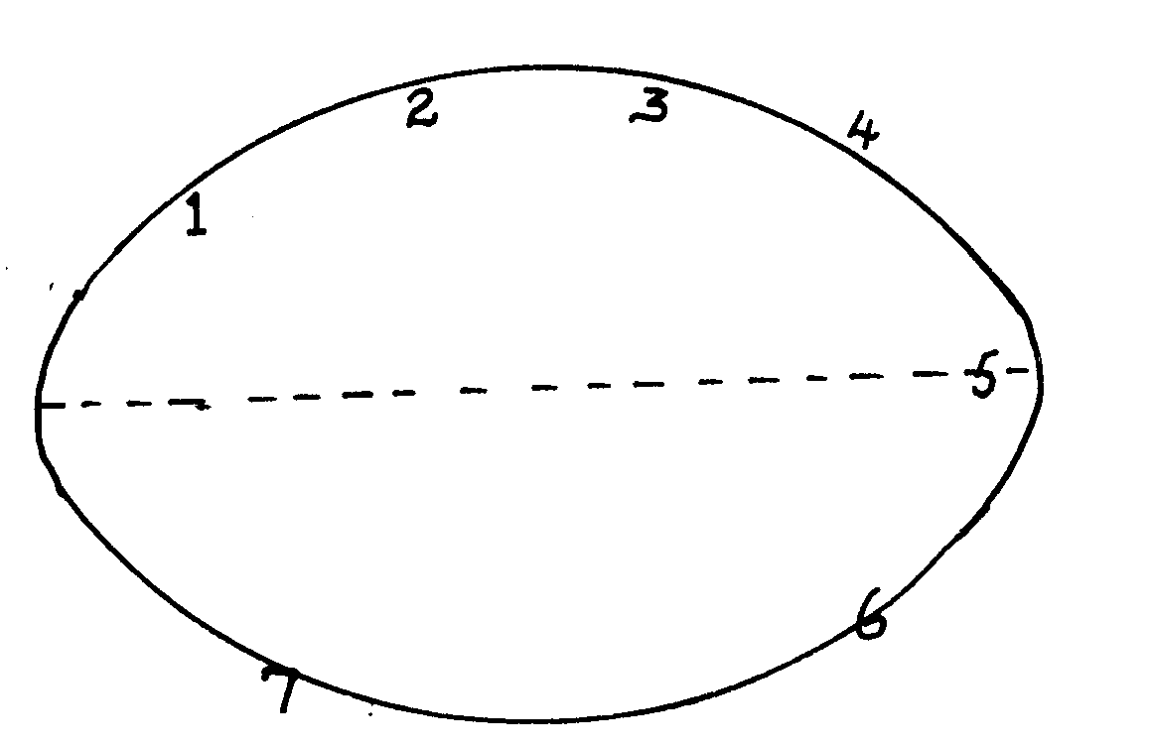
System development
System operation

1- problem recognition and definition
2- information gathering
3 requirement specification
4 system design
5 system construction (coding)
6 implementation and testing
7 review and maintenance
b) i) system entropy - is a system decay naturally overtime.
ii) changes in technology, new management policies, changes in new requirement
17. a) i) electronic device used in retail store to input and output data at the point
where a sales are transacted
ii) advantages of EPOS
• ensure correct prices are used at the check out cover.
• faster in data processing
• efficient
• enhances better control of business as stock is controlled
iii) Super market ,big companies
b)
• communication media
• network software
• communication devices
• data signals
c) i)
• twisted pair cables
• coaxial cables
• fibre optical cables
ii)
• Microwave
• Satellite
• Radio transmission

d) ` advantages
• flexible in operation
• can cover in a large geographical area
• can access a remote areas via satellites

disadvantages
• it is relatively difficult to establish and configure
• the initial cost is very high
18. a) i) Software engineer
• develop system and application software
• develop user and technical documentation for new software
• maintain and update the software to meet day to day requirement
  - Computer trainer.
• train people on how to use computers
• develop training reference materials
• guide learners on how to use and acquire knowledge through research.
• Prepare learners with ICT examinations
b) effect of ICT on
i) job opportunities
• job creation i.e. new jobs are created
• job replacement i.e. replacing of computer illiterate people / workers
• displacement of jobs that were formerly manual
ii) environment
• energy
• consumption
• paper consumption
• radiation
• pollution
  - Automated production
• assembly of vehicles in plants
• oil refineries
• food processing
• increased production
• creation of unemployment
- Sequential – records are stored and accessed in a particular order sorted using a key field.
Whereas indexed sequential uses both method random and sequential records are arranged in key sequence and position marked with indexes

19. a) i) cheque processing /survey
ii) marking of examination /bank
b) i) byte – group of 8 bits
ii) nible – group of 4 bits
- • tables
• forms
• reports
• queries
• macros
• modules

- • numbering
• bulleting
• spacing
• alignment
• indentation
- i) 00010110
- (0010 1001)
- i) data processing technique where data processing is divided into groups
physically located at different sites but connected to a central location.
ii) advantages:
 Errors easily corrected
 Better reliability
 Low cost
Enhanced security
 System failure does not affect others
 Encourages effective decision making
- Disadvantages / problems
 users have to be trained
 standards are difficult to maintain
 requires extra cost i.e. expensive
 there are programming techniques with micro- computers and mini- computers

SAMPLE PAPER 10
COMPUTER STUDIES PAPER 1
451/1
SECTION A ( 40 MARKS)
Attempt all questions in this section.

1. Explain the meaning of the following transmission impairments. (2mks)
a) Attenuation.
- Cross-talk
2. a) Define the term file organization. (1mk)
b) Explain two methods of file access. (2mks)
3. List four number systems that the design and organization of a computer may depend on. (4mks)
4. Explain the meaning of the following terms as used in computer communication (2mks)
a) Modulation
b) Demodulation
5. Using one’s complement, calculate 11011₂-111₂ and leave your answer in binary notation. (4mks)
6. List three types of computers that are classified according to the type of signal they use when functioning. (3mks)
7. In relation to DTP, explain the meaning of (2mks)
a) Pasteboard
- Masterpage
8. What is the main function of a primary key in a database. (1mk)
9. Apart from a computer, give three other elements that are needed in order to connect to the internet. (3mks)
10. a) Define the term virtual reality. (1mk)
b) Give three components of a virtual reality system. (3mks)
11. Highlight any two ways in which computers are used as industrial systems. (2mks)
12. Indicate the type of cell reference depicted by the following. (3mks)
a) $H$5
- H5
- H $ 5
13. List three components of a spreadsheet. (3mks)
14. State two documents that are needed during the process of mail merging. (2mks)
15. State any two components of a world wide web. (2mks)

SECTION B ( 60 MARKS)
Answer questions 16 and any other three questions from this section
16. a) Define the following terms as used in programming. (2mks)
i) Assembler
ii) Pseudo-code
b) With the aid of flowchart segments, highlight two differences between the REPEAT….UNTIL and WHILE…..DO statement structures. (4mks)
c) Give the name and use of the flowchart symbol below. (2mks)

A
A

- Name …………………………………………………………………………………
- Use
d) It is required that numbers from 5 to 100 in the series 5,10,15….100 are multiplied and the product displayed. Design a flowchart for solving the problem. (7mks)

17. a) The following diagram shows the stages of developing an information system.

REVIEW 7

IMPLEMENTATION 6

CONSTRUCTION 5

DESIGN 4

REQUIREMENT 3
SPECIFICATION

INFORMATION 2
GATHERING

PROBLEM 1
RECOGNITION

i) List any four methods that can be used to achieve the second stage in above. (4mks)
ii) List any four areas that have to be designed at the fourth stage. (4mks)
b) Explain the meaning of the following system characteristics. (4mks)
i) Entropy
ii) Controls
c) State the three functions of an information system. (3mks)
18. The diagram below shows various entities, their attributes and the relationship among them.
i)
CUSTOMER 1

CUSTOMER 2 RESIDENCE

CUSTOMER 3

ii) CUSTOMER 1 CUSTOMER 1 ID

CUSTOMER 2 CUSTOMER 2 ID

CUSTOMER 3 CUSTOMER 3 1D

iii) CUSTOMER 1 COOKING FAT

CUSTOMER 2 SOAP

CUSTOMER 3 TOOTHPASTE

a) Define the terms. (6mks)
i) Entity
ii) Attribute
iii) Relationship
b) Indicate the type of relationship depicted by the diagram above. (3mks)
i)
ii)
iii)
c) (a) Write the acronym DBMS in full. (1mk)
(b) State any three functions of a DBMS. (3mks)
d) List any three database models. (3mks)
19. a) State three characteristics of RAM. (3mks)
b) The capacity of a computers memory is 128MB. Calculate the maximum number of nibbles the memory can support. (4mks)
c) List any (5mks)
(i) Three pointing input devices
(ii) Two digitizing input devices.
d) State any three softcopy output devices. (3mks)
20. The following diagrams shows various transmission media for networking to computers.
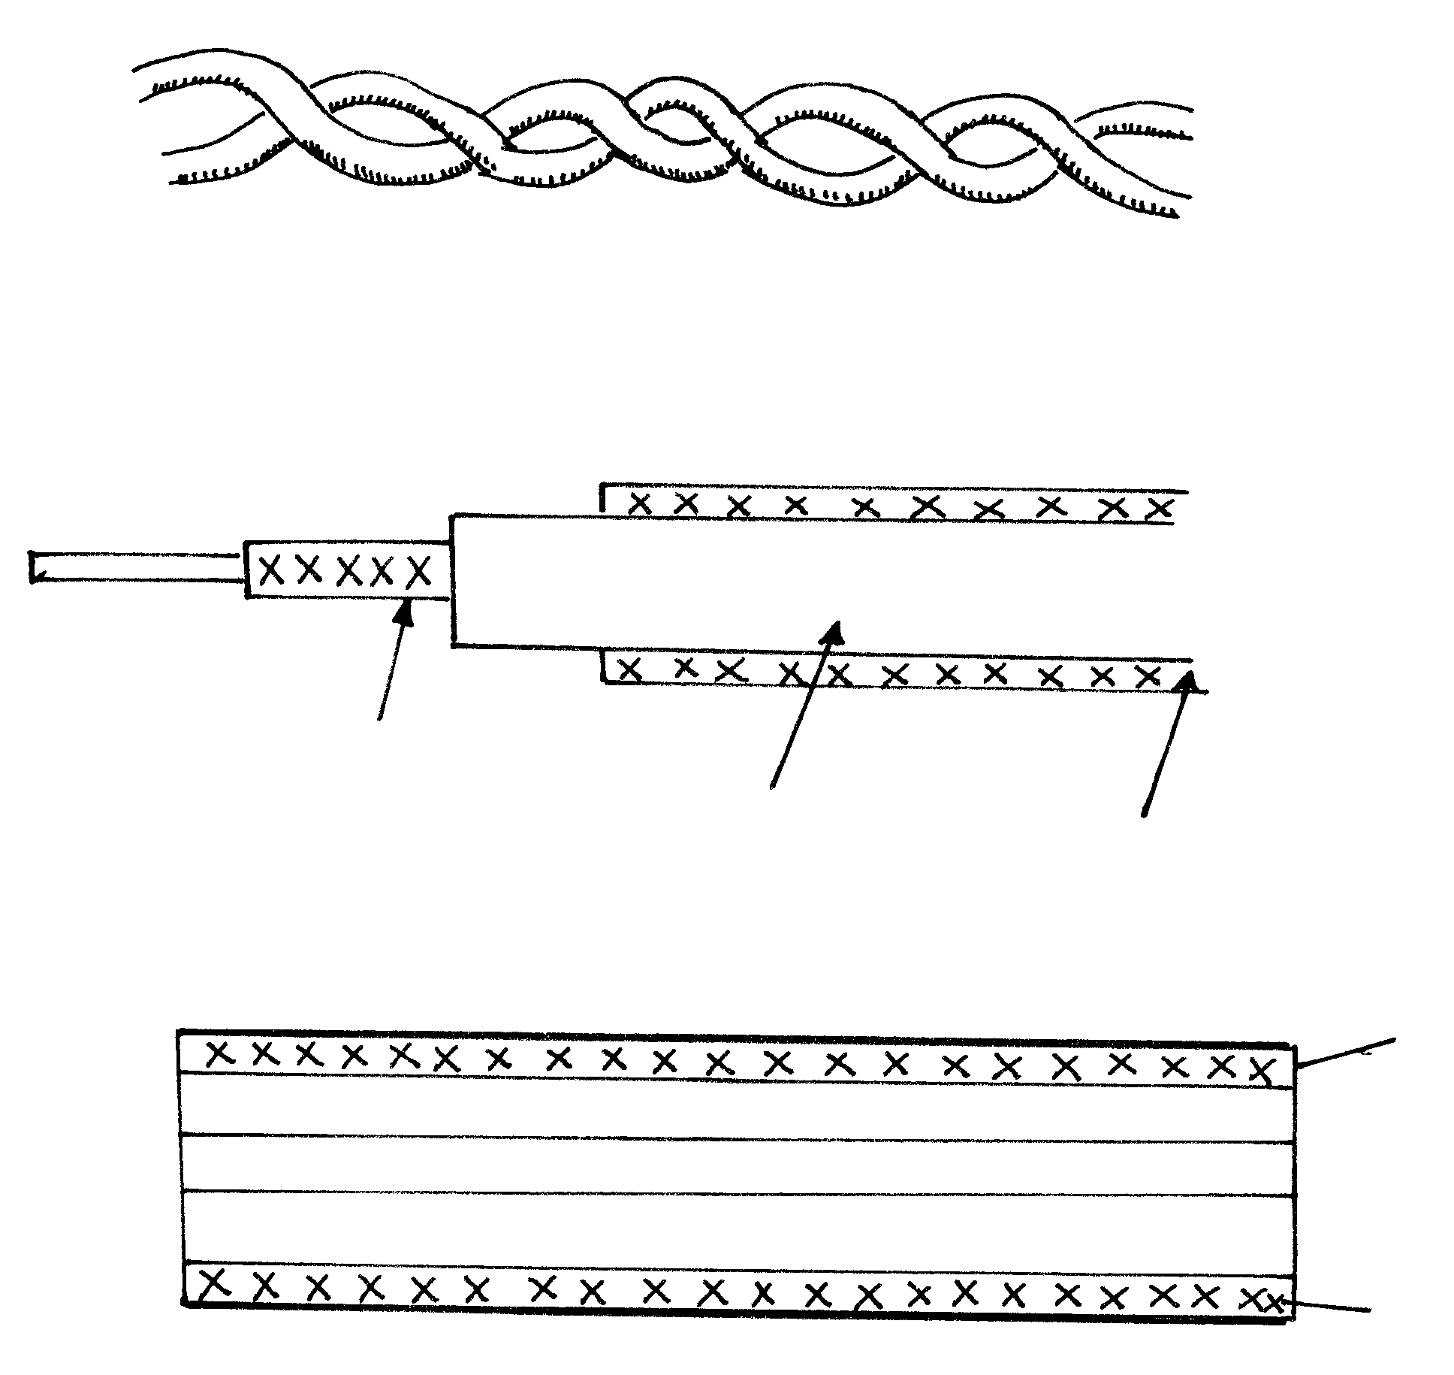
Inner conductor Inner Insulator
Outer conductor Outer insulator

JACKET

JACKET
CLADDING
CORE
CLADDING
i)
ii)
iii)
a) Name the transmission media shown in the diagrams above. (3mks)
i) ………………………………………………………………………………………………..
ii) ………………………………………………………………………………………………..
iii) ………………………………………………………………………………………………..

b) State any two advantages of using medium (i) over medium (iii) (2mks)
c) Explain the difference between a bridge and a gateway.
d) Give the use of the following networking devices. (6mks)
i) Network interface card(NIC)
ii) Router
iii) Repeater
iv) Explain the difference between a data Terminal Equipment (DTE) and Data Circuit – terminating Equipment (DCE) (2mks)

MARKING SCHEME
SAMPLE PAPER 10
451/1

1. a) Progressive decrease in magnitude and energy as a signal moves along a
transmission medium.
- Interline interference (Each 1 m x 2 = 2mks)
2. a) The systematic arrangement of files in a computer secondary memory. (1mk)
b)
i)Direct file access
ii) Indexed
iii) Serial - indexed (2mks)
3. - Hexadecimal
- Octals (Each 1 mk x 4 = 4mks)
- Decimal
- Binary
4. a) Changing of the digital data to analog data.
b) Changing of the analog data back to digital data.
5. 1011₂  - 111₂ 00100₂
- 000₂
00100₂ (4mks)
- Digital computer
Analog computer
Hybrid Computer (Each 1 mk x 3 = 3mks)

- a) An area in a DTP package where work is organized before placing it on the
printable area. (1mk)
b) pages used for general organization and format of a publication (1mk)

8. Used for relating records of similar characteristics within a database (1mk)
9. - Nic (Network Interface Card)
- Internet Service provider (Each 1 mk x 3 = 3mks
- Internet O/s
10. a) A situation / condition in which a person becomes psychological immersed in
an artificial environment generated by a computer system. (1mk)
b) - Headgear
- Gloves
- Body suit
- Virtual reality software.
11. - Process control
- CAD / CAM (Any two well highlighted each 1 mk x 2 = 2mks)
- Simulation.
12. a) Absolute
b) Relative (Each 1 mk x 3 = 3mks)
c) Mixed
13. - Work sheet
- Database
- Graphs
14. - Data source
- Main document
15. - LAN
- WAN (2mks)

16. a) i) A programming language that translates an assembly language into
machine language. (1mk)
ii) A set of statements written in a readable language (English – like phrases) expressing the processing logic of a program . (1mk)

b) REPEAT – UNTIL WHILE – DO

  No No Stop
Statements
Statement
Condition YES

Condition?

In repeat – until the statements are executed before the condition is tested while in the while do the condition is tested before the statements are executed .  4 mks
c) i) Connectors
ii) Used to join the logical flow (2mks)
17. a) i) Study of available documents
- Interview
- Questionnaires (Each 1 mk x 4 = 4mks)
- Observation
- Automated methods
ii) Flowcharts
- Data flow diagrams
- Entity relationship models
- Structured charts
- Entropy
Controls (Well explained each 2 mks x 2 = 4mks)
- - Supporting information processing
- Help in decision making
- Enable sharing information (Each 1 mk x 4 = 4mks)
18. a) i) Data entered in a particular column of a record
ii) Features of data e.g. format.
- Data of related features / attributes (Each 2 x 3 = 6mks)
- Many – to – one
One – to – one
Many – to – many
- i) Database management systems (1mk)
  - - Keep data / store data
- Process data
- Analyse and output information (Each 1 mk x 3 = 3mks)
d) - Flat model
- Related model
- Hierarchical model 1 x 3 = 3mks
19. a) - Volatile
- Limited
- Very expensive
b) 128 = 16
8 2 = 8 Million nibbles (4mks)

c) i) - Joystick
- Mouse
- Light pen
ii) Digitiser
- LED
Speakers (3mks)
Monitors
20. a) i) Twisted pair
ii) Coaxial (Each 1 mk x 3 = 3mks)
  - Fibre optic
b) - Installation equipment is cheap.
- It is readily available in most building (2mks)
c) Bridge – a network device that selectively determine the appropriate network segment for which a message is meant while a gateway is any device configured to provide access to wide area networks or internet.
d) NIC- Creates physical link between the computer and the transmission media.
Router – Interconnects different networks and directs the transfer of data packets from source to destination.
Repeater – boosts a weakening signal (6mks)
e) DTE is any device e.g. a computer workstation on a network, while a DCE ends /
marks the end of physical network circuit. (2mks)

